Chapter 7

Characterization of Gas – Liquid Flow Structures in Stirred Tank Reactors via Computer Automated Radioactive Particle Tracking (CARPT) and Computed Tomgraphy (CT)

7.1 Introduction
Gas-liquid stirred reactors are used in a variety of industrial applications like oxidations, hydrogenations, aerobic fermentations and manufacture of several pure products (Shah, 1992). Performance of such reactors depends on three key parameters (Smith, 1985): scale, stirrer design and gas input rate. These parameters in turn affect the gas holdup, power demand, gas-liquid mass transfer coefficient, mixing characteristics and the residence time distribution. The impeller design and rotational speed determine the mechanism of breakage of gas into smaller bubbles, dispersion of bubbles throughout the liquid, retaining bubbles in the liquid for a sufficient time and providing turbulent eddies to feed liquid to and from the gas – liquid interfaces. Global parameters like overall gas hold-up, power demand and overall gas-liquid mass transfer coefficients are very strong functions of the local fluid dynamics of the gas and liquid phases in the stirred tank However, several different combinations of the local fluid dynamics may result in similar global measurements. Hence, the practice of studying the variation of global parameters alone conceals detailed localized information. This local information may be crucial in the successful design of process equipment (eg., to avoid localized oxygen depletion Ranade and Van Den Akker, 1994; Gosman et al., 1992). The current literature on stirred tanks, although rich with information on the total power consumption, flooding phenomenon and overall gas holdup (Gezork et al., 2000; Nienow, 1996; Manikowski et.

al., 1994; Chapman et al., 1983;) is almost completely devoid of local measurements. Only a few studies, such as those of Lu and Ju (1987), Katsanevakis and Smith (1994), Morud and Hjertager (1996), Deen and Hjertager (1999), Wang, Dorward, Vlaev and Mann (2000); and Takahashi and Nienow, (1993); report the local quantities. A brief review of the pertinent experimental studies is provided in the following section.

  - Review of Previous Experimental Measurments
This review is intended to emphasize the fact that gas – liquid flows in stirred tanks exhibit a vastly complex, three dimensional and unsteady flow.

    - Qualitative Characterization of Flow through Photographic Studies

The principal mechanisms of the overall dispersion of gas into liquid, coalescence of gas bubbles and power requirements are largely determined by the behaviour of the gas – liquid mixture near the impeller blades. Van’t Riet and Smith (1973) characterized the flow of gas – liquid mixtures near a Rushton turbine in a stirred tank reactor using two different types of photographic measurements. They used a video camera that was mounted to a table below the tank and rotated with the impeller speed and also obtained high speed photographs with stationary cameras taken through the side of the tank. The measurements in the moving frame were performed on a tank of 45 cm diameter while the stationary measurements were performed on a tank of 30 cm diameter. Gas was introduced from below the impeller through a ring sparger. Neutrally buoyant polystyrene beads (2.0mm) were added to the flow for better visualization. Gas flow rates were small enough not to disturb the main liquid phase flow features. The presence of centrifugal effects causes the migration of gas to the vortex core and tends to form a cavity (refer to Figure 7-1). A large proportion of gas was observed to be drawn into the vortex core. The size of cavities behind impeller depends on the overall gas flow rate in the impeller region and the agitator speed. At very low tip speeds (quantified in terms of Cavitation number and Froude number) the natural buoyancy forces are greater than the centrifugal

forces and hence no stable cavity is formed. Cavitation number, or gas flow number, is the ratio of gas sparging rate to rate at which liquid is pumped by the impeller given by:
$\text{Fl}=\frac{Q_{G}}{{\text{ND}}^{3}}$ (7-1)
The Froude number is the ratio of inertial forces (represented by the impeller rotational speed) to the gravitational force given by:
$\text{Fr}=N_{\text{Fr}} = \frac{N^{2}D}{g}$ (7-2)

At higher impeller speeds some of the gas is drawn into the impeller region while the rest still escapes from the top surface. This results in formation of stable smooth cavities which persist over long periods (refer Figure 7-2).

Figure 7-1. Mechanism of Cavity Formation

With increasing impeller speed the bubbles become much more distorted, their cylindrical form follows the vortex structure and their roughened surfaces reflect the increased turbulence (refer figure 7-1). The turbulence also causes breakage of the cavities into tiny bubbles which then escape into the liquid bulk. It is this mechanism of cavity formation and its subsequent breakage and escape into the bulk liquid which is responsible for the good dispersion of gas into the fluid bulk. At higher tip speeds there is gas phase recirculation in the tank. Larger bubbles entering the impeller region are rapidly extended into a roll form and broken up. The frequency with which bubbles are broken up by the cavity are far higher than breakup of larger bubbles just rising up with the impeller discharge stream. With increasing gas flow rates the diameter of the circulating core tends to increase, but there is a natural limit to this when the liquid film between the blade and the gas filled vortex breaks down. In the following section a detailed description of cavity structures and quantification of flow regime is provided.

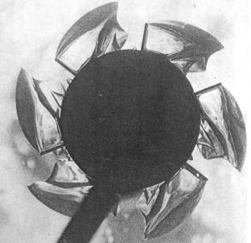

Figure 7-2. Stable Cavity Formed at Higher Impeller Speeds and Gas Sparging Rates (Reproduced from Bruijn et. al., 1974)

    - Classification of Cavity Structures

Gas filled cavity structures control the energy dissipation, spatial gas – phase distribution in the liquid bulk, flooding conditions and so on. The form and configuration of gas filled cavities depends on transport properties (Takahashi and Nienow, 1992), gas flow rate and impeller speed, and the number of blades (Warmoeskerken and Smith, 1982). A number of different researchers have worked on classifying the structure of gas cavities like Chapman et. al. (1983), Warmoeskerken et. al. (1981), Warmoeskerken and Smith, 1982, Ismail et. al. (1984), Takahashi and Nienow, (1992), Bombac et. al. (1997), etc. Here we provide a brief review of their findings. We begin by describing the findings of Chapman et. al. (1983).
The six bladed Rushton turbine is one of the popular gas dispersing impellers since the disc forces all the inflowing gas to pass through the high shear impeller region, ensuring sufficient break – up of the gas stream into bubbles and effective dispersion of the bubbles throughout the vessel. At low impeller speeds a large gas cavity covers the impeller. As the impeller speed increases the cavity shape modifies itself to fit the shape of the trailing vortex and at still higher speeds the breakaway points moved inwards along the blade forming vortex cavities. As a small amount of gas is introduced into the system, it migrates to the low pressure regions forming vortex cavities behind the impeller blades and therefore increasing the pressure in this area. The consequence of this is a reduced pressure difference over the blade and a slight drop in drag and power consumption. As gas flow rate is increased an increasing number of cavities are formed, streamlining the impeller and further reducing the drag. Eventually all six cavities reach a maximum size and the impeller pumping capacity is reduced to a minimum. Warmoeskerken et. al. (1981) proposed that three large cavities form simultaneously, causing a definite drop in the power consumption at a given gas rate, after which any further decrease can be explained by the reduction in the mean density of the pumped liquid.
Constant Gas Flow Rate with Increasing Impeller Speed:
At low speeds the tips of the blades are surrounded by liquid and the power number remains high because of the presence of two low pressure vortices at the back of each

blade. As impeller speed is increased, a large cavity forms over the upper half of the blade causing a reduction in power number. At a slightly higher speed the cavity covers the whole of the back face of the blade and a minimum occurs in the gassed power number. Further increases in the speed cause a rise in the power number as the size and number of large cavities fall and their shape tends towards those of vortex cavities. At high enough impeller speeds, recirculation of gas to the impeller becomes significant and the power number drops slightly again. The impeller speed required to achieve the resulting maximum is commonly designated N_{R}.
Ismail et. al. (1984) attempt to predict the appearance of gas cavities through power consumption measurements.
They classify the cavities into two types:
a) Cavities seen during Flooding
They find that at very low impeller speeds, the air stream formed large bubbles at the sparger holes or on the lower surface of the impeller disc, but was not dispersed by the impeller blades. Large bubbles thus formed, passed radially between the blades and left the disc from its edge. They ascribe the appearance of the first minimum on the Relative Power Demand (RPD) vs Impeller speed (N) curve to the formation of these large bubbles (refer to Section 7.2.4). At the rotational speed slightly above the first minimum, some of the bubbles enter into the rear part of the inner edge of the impeller blade. At this point, the RPD abruptly increases to the first maxima. As the sparging progresses, almost all the bubbles enter the rear part of the impeller blades at n = n_{c1}. Sparging and initial dispersion causes abrupt increase in gas holdup in the vessel. A convenient definition for flooding is the region where impeller speed is less than the impeller speed for complete circulation (i.e. N<N_{c1.} , refer to Figure 7-3). They found that increase in impeller speeds beyond the critical speed resulted in significant dispersion of gas characterized by the appearance of :
b) Unstable Large Cavity:
They found that for some blades, the gas film was produced from the inside blade edge to the blade tip and was then elongated into the liquid to be dispersed into smaller bubbles. Large cavities were not observed on other blades at this time. The cluster of bubbles left

the blades at a midway point between the tip and the inner edge of the blade. The situation was not steady since the large cavity and cluster type cavity replaced each other with time on the same blade.
Bombac et. al. (1997) provide a quantitative characterization of the different cavity structures
- Vortex Clinging Structure (VC): The frequency analysis of structural function for vortex clinging structures shows principal frequencies corresponding only to the blade passage frequencies and its higher harmonics.
- Clinging Cavities (1L): Increasing gas flow rates results in clinging cavities. Further increase in gas flow rate results in the formation of the first large cavity. Analysis of cavity presence over longer periods suggested that a large cavity appeared on various blades randomly; it moved from blade to blade. In the frequency domain the random appearance of large cavities on various blades corresponds to the rise of significant subharmonics of the blade frequency $\left(f_{b}\right)$ such as f_{b}/6,f_{b}/3, f_{b}/2, 2f_{b}/3 and 5f_{b}/6.
- Two Large Cavities (2L): Cavities follow each other in the same sequence; one large cavity is followed by two vortex clinging cavities, and so on. Such a configuration is present only for a very short time and is followed by the appearance of two large cavities, but never on adjacent blades. In the frequency domain two significant subharmonics f_{b}/3 and 2f_{b}/3 predominate.
- Three large and Three Clinging Cavities (S33): The beginning of the S33 structure can be seen by the appearance of a peak at f_{b}/2. The S33 structure is described (Bruijn et. al., 1974;van’t Reit and Smith, 1973) as a combination of three large and three clinging cavities. The large cavities are present on the same blade.
- Three Smaller and Three Larger Large Cavities (L33): L33 is described (Nienow, 1990; Warmoeskerken and Smith, 1982) as a combination of three smaller and three larger large cavities. The large and small cavities are presently alternately on each of the blades. A rise in the coefficient of f_{b}/2 is seen till its value becomes almost equal to that of f_{b}.

- Ragged Cavity (RC): On increasing the gas flow rate further, according to Warmosekerken and Smith (1985), the stable L33 structure reverts to six symmetrical clinging cavities, and at higher impeller speeds the changeover passes through a regime with six large cavities of identical size, which are described as violently vibrating and referred to as the ragged cavity structure (Nienow, 1990). These cavities are each of different sizes with sporadic appearance of larger cavities. At higher gas flow rates, a longer absence of any cavity on a particular blade was also possible.
Hence for a fixed impeller speed increase in gas flow rate results in the following sequence of cavity structures appearing: Vortex Clinging (VC), One large cavity (1L), Two Large Cavities (2L), Three Large cavities and three small cavities (S33), Three larger large cavities and three smaller small cavities (L33) and finally ragged cavity structure (RC) before the transition to flooded condition occurs. The vast majority of industrial operations take place in the large cavity regime (Smith, 1991). Bombac et. al. have created a detailed map of Froude number vs Cavitation numbers (equation 7-1 and 7-2) clearly identifying which regions correspond to which of the above cavity structures (refer Figure 7-3).

Figure 7-3. Flow Regime Map for CT+CARPT+CFD Data Obtained in Stirred Tank Reactor

    - Power Consumption Measurements

A number of researchers like Hughmark (1980), Midoux and Charpentier (1984), Michel and Miller (1962), Nagata (1975), Nienow et.al. (1977,1988), van’t Riet and Tramper (1991), Rushton et.al. (1950), Smith et. al. (1977 and 1993), Warmoeskerken (1986), Warmoeskerken and Smith (1988), etc. report power uptake measurements in two phase flows in stirred tank reactors. According to Van’t Riet et. al. (1976) the power consumption in an aerated vessel is largely controlled by the formation of gas cavities behind the stirrer blades. The sparger gas inflow rate is one of the variables which strongly influences the cavity shape. They report comparisons of power curves with and without recirculation which clearly show that the recirculated gas inflow to the cavity influences the power consumption. They make general observations like, agitators with larger number of blades have smaller cavities at a given gas inflow rate, increase in gas flow rate decreases the fraction of old gas leaving the impeller, and increasing the impeller speed increases the fraction of old gas leaving the impeller region.

Rushton et. al. (1950) were the first to apply dimensional analysis in order to predict the dependency of the liquid mixing mechanical power requirement for systems containing liquid only. For specified geometry, they showed that , the necessary power $P_{o}$ can be obtained as:
$N_{p}=\frac{P_{o}}{ρ_{L}N^{3}D^{5}}= C_{3}N_{\text{Re}}^{x}N_{\text{Fr}}^{y}$ (7-3)
where $N_{p}$ is the power number, $N_{\text{Re}}=\frac{{\text{ND}}^{2}}{ν}$ is the Reynolds number and $N_{\text{Fr}}$ is the Froude number defined in equation (7-2). In fully baffled tank y=0, and in the turbulent regime $\left(N_{\text{Re}} > {\text{10}}^{4}\right)$ the above equation reduces to:
$N_{p}=C_{4}$ (7-4)

where $C_{4}$ is a constant specific to a particular impeller configuration. Correlations of $N_{P}$ for various types of impellers have been provided by Rushton et. al. (1950), Bates et. al. (1962) and summarized by Nagata (1975) and Oldshue (1983).
According to Hasan and Robinson (1977) the reduction in mechanical power drawn by an impeller under sparged conditions does not depend merely on the change in the volume density of the tank contents resulting from the addition of dispersed gas bubbles but also is strongly influenced by the impeller and tank geometry, the impeller rotational speed, liquid phase physicochemical properties, and the gas sparging rate. Based on dimensional analysis they showed the Relative Power Demand (RPD) to depend on the following dimensionless variables:
$\text{RPD}=\frac{P_{g}}{P_{o}}=C_{1}N_{\text{We}}^{m}{\text{Fl}}^{n}{\left(\frac{ρ_{L}}{ρ_{D}}\right)}^{g}$ (7-5)
where $N_{\text{we}}=\frac{{ρD}^{3}N^{2}}{σ}$ the Weber number represents the ratio of inertial force to force due to surface tension. The concept of cavitation number (or aeration number) was first used by Ohyama and Endoh (1955) who measured the RPD for air – water dispersions using a variety of impeller types. Ohyama and Endoh (1955) performed all their measurements at constant impeller speed and varying gas flow rates. For this case they found that increasing the aeration number (i.e. gas flow rates) decreases the power consumption (refer Figure 7-4).

Figure 7-4. Change in RPD with Increasing Gas Sparging Rate at Fixed Impeller Speed

Michel and Miller (1962) and Vares (1975) found that the change in RPD with change in $N_{A}$ is not consistent but is rather dependent on whether $N_{A}$ is changed by altering gas sparging rate (Q_{G}) or impeller rotational speed (N). If Q_{G} is varied at constant N, continuously decreasing functions similar to those of Ohyama and Endoh (1955) are obtained with increasing Fl. However, if N is varied at constant Q_{G}, a separate curve is obtained for each gas flow rate, and these show that the RPD increases slightly with increasing Fl until an asymptotic limit is reached such that the RPD is constant. The limiting constant value of RPD depends on Q, decreasing as Q increases. Michel and Miller (1962) measured $P_{g}$. For various liquids (water, organics, aqueous solutions of organics) in a stirred tank with six bladed Rushton turbine Hassan and Robinson (1977) fitted a correlation of the form:
$P_{g}=C_{8}{\left(P_{o^{2}}{\text{ND}}^{3}/Q^{0\text{.}\text{56}}\right)}^{0\text{.}\text{43}}$ (7-6)
They found that the correlation fitted the experimental data of Sachs (1950), Ohyama and Endoh (1955), Bimbinet (1959), and Michel and Miller (1962) within +/- 30% if the exponent 0.43 was changed to 0.45 and with $C_{8}$ = 0.72. Pharamond et. al. (1975) evaluated RPD for air – water dispersions and proposed a correlation of the form:
$1\text{.}0− \frac{P_{g}}{P_{o}} = \text{96}\left(Q/V\right)D^{0\text{.}\text{63}}$ (7-7)
Hassan and Robinson (1977) studied the variation of RPD with gas flow rate but not with rpm at constant gas flow rate. Hence, the correlation they proposed is limited because the variation of RPD with N at constant gas flow rate is very different.

Luong and Volesky have proposed the following correlation for Newtonian fluids:
$\frac{P_{g}}{P_{u}}=0\text{.}\text{497}{\left(\frac{Q}{{\text{ND}}^{3}}\right)}^{−0\text{.}\text{38}}{\left(\frac{N^{2}D^{3}ρ}{σ}\right)}^{−\text{.}\text{18}}$ (7-8)
This correlation is restricted to systems with $σ = \text{55} − \text{72} {\text{dyn}}/{\text{cm}}$ and an impeller to vessel ratio of 1/3. The equation is not applicable to systems like CCl₄. Hence in order to correct for these limitations, Hughmark (1980) proposed a correlation, using various data sets, of the form:

$\frac{P_{g}}{P_{u}} = 0\text{.}\text{10}{\left(\frac{Q}{\text{NV}}\right)}^{−\text{.}\text{25}}{\left(\frac{N^{2}D^{4}}{{\text{gD}}_{\text{width}}V^{2/3}}\right)}^{−1/5}$ (7-9)
where D_{width} is the impeller blade width and V is the liquid volume. The average absolute deviation between calculated and experimental values is 8.5%. The above correlation also fits the data of Bimibinet (1959) and the overall absolute deviation is 11.5%. Chapman et. al. (1983) propose a correlation of the following form:
${\text{Po}}_{g}=\frac{P_{g}}{ρ_{L}N^{3}D^{5}} = \text{Po}\left(P_{g}/P\right)∝P_{g}$ (7-10)
The correlations of Michel and Miller (1962) and of Hughmark (1980) are often used in the literature. Midoux and Charpentier (1984) recommend Michel and Miller’s (1962) correlations for estimating the gassed power uptake. However van’t Riet and Tramper (1991) state that Michel and Miller’s correlations are applicable only over a limited range of parameters.
Hughmark’s correlation is considered to be quite good (Hughmark, 1980, Van’t Riet ad Tramper, 1991) since accurate power uptake measurements are difficult to perform. However, Warmoeskerken (1986) found both Michel and Miller’s (1962) and Hughmark’s (1980) correlations to overestimate the gassed power demand. Cui et. al. (1996) proposed a correlation for power uptake using 739 data points extracted from a number of different researchers. The variations of RPD $\left(\frac{P_{g}}{P_{u}}\right)$ vs flow numbers (from Warmoeskerken, 1986) indicate that for the same flow number there is considerable variation in the RPD. Hence, the RPD depends on more parameters than the flow number alone. The expressions from Hughmark (1980) and Michel and Miller (1962) have a common drawback i.e. the RPD does not become 1 for ungassed conditions. Cui et. al. (1996) develop a correlation for 1.0-RPD as a function of gas volume flow rate, stirrer speed, impeller diameter, tank diameter. Here the basic assumption is RPD under gassed conditions will always be lesser than 1.0. Cui et. al. propose correlation of the form:
$1−\frac{P_{g}}{P_{u}} = f\left(\frac{Q_{g}N^{0\text{.}\text{25}}}{D^{2}}\right)$ (7-11)

A plot of the LHS vs the RHS reveals almost one single curve(refer to figure 7-5). They also conclude that power uptake is not sensitive to T/D (tank diameter to impeller diameter) ratio. Cui et. al. (1996) have also shown that (refer figure 7-6) their correlation fits the data of a number of other researchers as well (Bruijn et. al., 1974; Hudcova et. al., 1989; Nagata, 1975; Nienow, 1977; Smith et. al., 1977; Warmoeskerken, 1986; Warmoeskerken and Smith, 1988). The variation shows that there are two distinct linear portions. The change in slope is attributed to a change in regime. The initial portion has a very steep slope while the latter portion has a smaller slope. The correlations obtained for these two portions are given below:
$\frac{Q_{g}N^{0\text{.}\text{25}}}{D^{2}} ≤ 0\text{.}\text{055} : \begin{matrix} & & \end{matrix}1−\frac{P_{g}}{P_{u}} = 9\text{.}9\left(\frac{Q_{g}N^{0\text{.}\text{25}}}{D^{2}}\right)$ (7-12a)
$\frac{Q_{g}N^{0\text{.}\text{25}}}{D^{2}} > 0\text{.}\text{055} : \begin{matrix} & & \end{matrix}1−\frac{P_{g}}{P_{u}} = 0\text{.}\text{52} + 0\text{.}\text{62}\left(\frac{Q_{g}N^{0\text{.}\text{25}}}{D^{2}}\right)$ (7-12b)
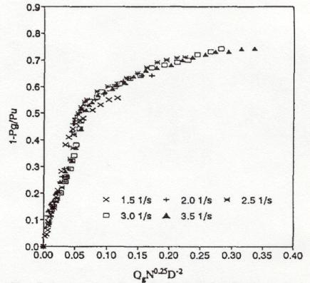

Figure 7-5. Reduction of Power Uptake by Single Impeller in a Gassed STR from Warmoeskerken, 1986 (T=1.2m, D=0.48 m, H=T)

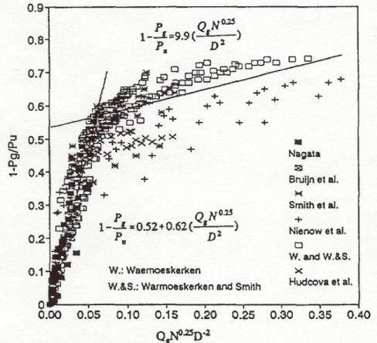

Figure 7-6. Comparison of Power Uptake Predicted by Cui et. al.’s Correlation with other Correlations

The relative errors for both parts are below 6%. The above correlation was developed only for the air – water system. Hence the sensitivity of the correlation to different combinations of working fluids is not known. Xu et. al. (1997) measure power consumption by a torque transducer mounted on the agitator shaft. They measure holdup by visual observation and the discharge flow number using tracer particles.

    - Overall Gas Holdup Measurements
A number of different researchers report the overall gas holdup measurements (refer to reviews by Pandit and Joshi; 1982; and Patwardhan) and found that as the impeller speed was increased the overall gas holdup increased. The overall holdup also increases with increase in gas flow rate. Flooding is observed at lower impeller speeds with higher gas inflow rates. At constant gas flow rates a bypass zone is observed for small agitator

speeds where the gas bubbles flow through the tank without recirculation. With increasing N the gas phase is effectively dispersed in the loading zone. With further increase in impeller speed the gas holdup reaches a maximum and then there is no further increase in the holdup with increase in impeller speed. This is the flooding zone. Loiseau et. al. (1977) have proposed two correlations for overall gas holdups $\left(ε_{g}\right)$ one for foaming and the other for non-foaming solutions. The correlation for non – foaming solutions is:
$ε_{g} = \text{.}\text{011} u_{s}^{\text{.}\text{36}}s^{−\text{.}\text{36}}μ^{−0\text{.}\text{056}}{\left(ε_{A}+ε_{D}\right)}^{0\text{.}\text{27}}$ (7-13)
and for foaming solutions is:
$ε_{g} = \text{.}\text{0051}u_{s}^{\text{.}\text{24}}{\left(ε_{A}+ε_{D}\right)}^{\text{.}\text{57}}$ (7-14)
The accuracy of (7-13) is 20% while that of (7-14) is 30%. $ε_{A}$ is the mechanical agitation power in gas – liquid dispersion and $ε_{D}$ is the sparged gas isothermal expansion power per unit volume of clear liquid $\left[ε_{D}=ρ_{G}Q_{G}\text{RT}/M_{G}V_{L}\text{ln}\left(p_{s}/p_{o}\right)\right]$. Midoux (1977) reported good agreement of (7-14) with experimental data if the LHS is replaced by ${ε_{g}}/{\left(1−ε_{g}\right)}$. Hughmark (1980) has proposed a correlation for the gas holdup $\left(ε_{g}\right)$ in a stirred tank reactor as:
$ε_{g} = 0\text{.}\text{74}{\left(\frac{Q}{\text{NV}}\right)}^{0\text{.}5}{\left(\frac{N^{2}D^{4}}{{\text{gD}}_{i}V^{2/3}}\right)}^{1/2}{\left(\frac{D_{p}N^{2}D^{4}}{{σV}^{2/3}}\right)}^{1/4}$ (7-15)
The average error using this correlation was 8%. D_{p} is bubble diameter. He has also proposed a correlation for the interfacial area per unit volume of gas – liquid mixture as:
$a=1\text{.}\text{38}{\left(\frac{gρ}{σ}\right)}^{0\text{.}5}{\left(\frac{Q}{\text{NV}}\right)}^{1/3}{\left(\frac{N^{2}D^{4}}{{\text{gD}}_{i}V^{2/3}}\right)}^{\text{.}\text{592}}{\left(\frac{D_{p}N^{2}D^{4}}{{σV}^{2/3}}\right)}^{\text{.}\text{187}}$ (7-16)

    - Local Gas Holdup Measurements
One of the earliest methods of void fraction measurements by gas dispersion in a stirred tank was the vaccum sampling technique (Nienow et. al., 1977). Nagase and Yasui (1983) modified this method by incorporating a pair of resistivity probes for measuring

local holdups and local bubble sizes. Their experiments were performed in a tank of diameter 0.25 m (D=T/2) at one rpm (4.78rps, Fr= 0.29) and three gas flow rates
(4.92e-4, 8.82e-4 and 11.8e-4 m³s⁻¹) corresponding to Fl = 0.0527, .0945 and 0.1264. Based on the flow regime map developed by Bombac et. al. (1997, refer to Figure 7-3) these runs belong to the cavity types 2L, S33 and L33, respectively (refer to section 7.2.3 for discussion of these cavity types). For each of these conditions measurements are available at five different axial planes (Z/T =0.33, 0.4, 0.48, 0.72 and 0.96) and six radial locations. For the 2L cavity structure at Z=10 cm (Z/T = 0.33, impeller plane) the holdup starts increasing as we move away from the shaft and peaks near the wall and starts going down very close to the wall. A similar trend is observed for the S33 and L33 conditions (refer to Figure 7-7a). The peak holdup value however increases from 2L to L33. At Z =12 cm (Z/T = 0.4) for all three conditions the holdup starts rising from near the shaft and reaches a maximum value before the impeller region and remains more or less constant until 4/5 of the tank radius (refer to Figure 7-7b). The maximum values once again are the highest for the L33 structure. At z=18 cm (Z/T = 0.48) the holdup has a high value near the shaft and then reach a peak value just beyond the radial position corresponding to the impeller tip and then starts falling to zero as it approaches the wall. At z = 24 cm (Z/T = 0.72) the holdup has two peaks, a small one near the shaft, and a larger one closer to the wall. There is a minimum between these two close to the radial position corresponding to the impeller. They report that the measurements near the impeller region are not accurate and they have not attempted to explain the appearance of the second maximum near the wall.
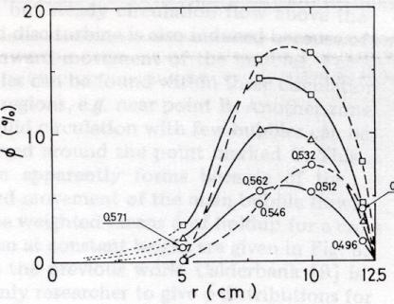
Fl=.12
Fl=.09
Fl=.05
ε_{g}

Figure 7-7(a). Radial Profile of Gas Holdup at Impeller Plane at Fr = 0.29 and Fl = 0.05,0.09 and 0.12

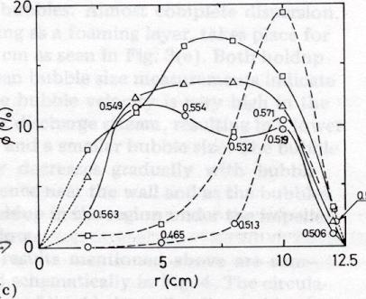
Fl=.12
Fl=.09
Fl=.05
ε_{g}

Figure 7-7(b). Radial Profile of Gas Holdup at Z/T=0.4 at Fr=0.29 and Fl=0.05,0.09 and 0.12

Barigou and Greaves (1992) used two pairs of LED/photo detectors for holdup measurements. Impedance probes take advantage of the change of either resistivity or capacitance according to the phase considered. They found that increasing impeller speed increases gas holdup at every point and increases uniformity of holdup distribution. Increase in gas flow rate causes an almost uniform rise in gas holdup in the bulk, and reduced gas circulation in the lower region of the vessel. They report holdup measurements at 22 points in the midplane between baffles. Figueiredo and Calderbank (1979) used such probes to determine the bubble size distribution in an aerated stirred tank. Probe tips are normally of small diameters and enable detection of very small bubbles. Frijlink (1987) used optical probes (based on different refractive index of phases) for local void fraction measurements in gassed suspension reactors. Bombac et. al. (1997) and Zun et. al. (1995) used resistivity probes to measure local void phase holdup distribution. They define a structural function which as :
$\begin{aligned}M_{p}\left(x,t\right) = \\ \end{aligned}$ (7-17)

where $p = \left\{L, G, S\right\}$.
The pulse length at constant impeller speed is proportional to the detected cavity size. The pulse length of a large cavity is a few times larger than the pulse length of a vortex or clinging cavity. Frequency analysis of the structural function $M_{p}$enables the presentation of the significant frequencies of an appearing gas phase. The local void fraction is given by
$α\left(x\right) = {\text{lim}}_{Δt → ∞} \frac{1}{Δt} {\text{lim}}_{δ→0}\int_{t}^{t+Δt}{M_{G}\left(x,t\right)\text{dt}}$ (7-18)
where $Δt$denotes total sampling time and $δ$ interfacial thickness. A discrimination procedure transforms the R-probe response into a binary signal. Bombac et. al. (1997) have provided detailed local void holdup profiles for three of the basic cavity structures i.e. the L33, S33 and VC structures (refer to Section 7.2.5). Under L33 conditions the liquid pumping capacity was weakened. The reduced pumping capacity resulted in a weak two – phase circulation in the liquid bulk especially below the impeller where 30% of liquid bulk remained undispersed. By increasing the impeller speed a transition from L33 to S33 occurred. This increased the liquid phase recirculation which also increased significantly the volume integrated holdup values. In S33 despite increase in the discharge flow a considerable part of the liquid bulk below the impeller remains undispersed.

7.2.6 Local Bubble Size Measurements

Kawecki et. al. (1967), Takahashi et. al. (1992), Parthasarthy and Ahmed (1990) measured the bubble size distributions in a stirred vessel by withdrawing the dispersion outside the tank into a small transparent column of square cross section and photographing them. Barigou and Greaves (1992) and Lu et. al. (1993) measured the Bubble Size distributions (BSD) using capillary suction tube and photoelectric capillary methods respectively. Their findings are summarized below:
a) Average bubble size decreases with increase in impeller speed and increases with increase in gas flow rate in general.

b) The BSD however, varies significantly with the position of the measurement location.
c) In the impeller region the BSD is strongly dominated by the strength of the trailing vortex and the cavity structure behind the blade. In this region with increasing Flow numbers the bubble sizes increase and at a certain flow number there is an inflection in the curve (refer to Figure 7-8).This inflection location corresponds to a similar point on the RPD vs flow number curve (Refer Figure 7-8).
d) In the upper circulation zone the BSD depends on the impeller dispersion ability. Increase in impeller speed is observed to promote coalescence and therefore an increase in the bubble size.
e) In the lower circulation zone an increase in impeller speed initially causes an increase in the bubble size until a maximum is reached. Beyond this speed further increase in the impeller speed promotes redispersion of the bubbles by the impeller.
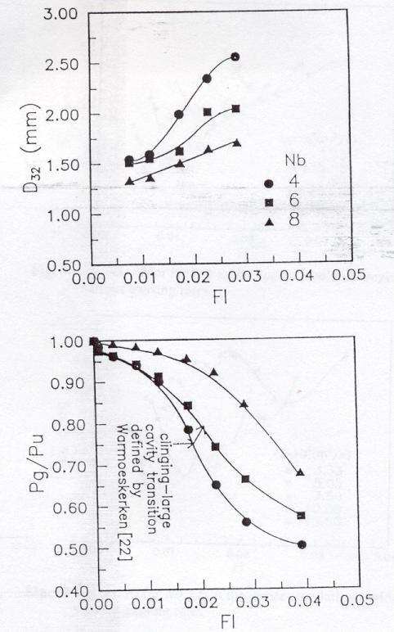

Figure 7-8. Bubble Size and RPD Variation with Fl at Impeller Tip (Lu et. al., 1993).

7.2.7 Liquid Velocity Measurements
Local liquid velocity measurements have been provided by Lu and Ju (1987) in a tank of diameter 0.28 m using Hot wire anemomemtry (HWA). The error associated with the velocity measurements are of the order of 5-25%. Morud and Hjertager (1996) and Deen and Hjertager (1999) perform Phase Doppler Anemometry (PDA) and PIV measurements in a 0.22m tank. However, their tank has a dished bottom and their impeller clearance is 1/2T while ours is 1/3T. Further, the PIV measured liquid velocities are available at Fl=0.029 and Fr=0.81. We do not have data at these high Fr numbers in our study. Hence direct comparisons of the liquid velocity data (from CARPT) or the local holdup data (from CT) with values in the literature is not feasible. For further details of velocity measurements refer to Chapter 2 (Section 2.3).

Hence, for gas-liquid systems there is a clear need for accurate and reliable information of the fluid dynamics of the liquid and gas phase, especially at higher gas volume fractions. While a detailed qualitative picture exists, a clear need for a quantitative map of the flow structures emerges from the above analysis. Hence, in this work we address the issue of creation of a reliable database for the estimation of local gas holdup measurements using the technique of Gamma (γ) ray Computed Tomography (CT) and determining the detailed local liquid velocity structures using the technique of Computer Automated Radiaoctive Particle (CARPT). In the following sections the details of the Computed Tomography (CT) setup is provided. Details of the CARPT set up are provided in Chapter 3 and in our earlier studies (Rammohan et. al., 2001a; Rammohan et. al., 2001b and Rammohan et. al., 2001c).

  - Experimental Studies

    - Details of Computed Tomography
When a beam of electromagnetic radiation passes through matter, its intensity decreases because a fraction of the photons are absorbed or scattered by the intervening medium. This reduction in intensity is referred to as attenuation, and the extent of attenuation

depends on the density of the intervening medium. This property is the key to back-calculating the density of the intervening medium depending on the attenuation of a beam of radiation passing through it. This property is quantified by the Beer – Lambert’s Law (Kak and Slaney, 1988) given by:
$\frac{I}{I_{0}} = \text{exp}\left[−\int_{l\left(x,y\right)=0}{μ_{\text{eff}}\left(x,y,z\right)\text{dx}}\right]$ (7-19)
where is the effective point total attenuation coefficient in the domain, and is the product of $\overset{\text{\sim }}{μ}\left({\text{cm}}^{2}g^{−1}\right)$ and $ρ\left(g/{{\text{cm}}^{3}}\right)$. While $\overset{\text{\sim }}{μ}$ is a material property, the density of the intervening medium is in general not uniform and there is a distribution of densities in the system. This is characterized by the distribution of densities in the path of the radiation. The tomography problem is an inverse problem of reconstructing the function $μ_{\text{eff}}\left(x,y\right)$ based on measurements of the line averaged attenuation along various chords in the system of interest. In general, the function $μ_{\text{eff}}$can vary with time and typically does in multiphase systems that are inherently unstable. But the CT set up used for our studies due to constraints in collecting statistically significant photon counts, inertia and finite mechanical speed of operation, cost of detectors is limited to obtaining time averaged holdup measurements. In our CT set up the projection data is acquired over a sufficiently long time and the entire set of projections is assembled to reconstruct a density distribution that is representative of the time averaged volume fraction distribution over the entire period of acquisition. This process of measuring time- averaged attenuations is repeated all around the column and at various chords. From these measurements the time averaged effective attenuation coefficient $\left(\left\langle μ_{\text{eff}}\left(x,y\right)\right\rangle \right)$ is obtained in every pixel by reconstructing the image from the entire set of projection measurements. The total mass attenuation coefficient can be represented as the sum of the individual phase mass attenuation coefficients weighted by the respective volume fractions. This is represented as:
$$\left\langle μ_{\text{eff}}\left(x,y\right)\right\rangle =μ_{l}\left\langle ε_{l}\left(x,y\right)\right\rangle +μ_{g}\left\langle ε_{g}\left(x,y\right)\right\rangle$$

$\left\langle ε_{g}\left(x,y\right)\right\rangle =\frac{\left\langle μ_{\text{eff}}\left(x,y\right)\right\rangle −μ_{l}}{μ_{g}−μ_{l}}$ (7-20)
Evaluation of the time averaged phase holdup distribution function by equation (7-20) depends on the accurate reconstruction of the total mass attenuation coefficient $\left\langle μ\left(x,y\right)\right\rangle$ distribution from the individual projection (attenuation) measurements. There are different algorithms available for this reconstruction as outlined by Kumar (1995). In the current study we use the Estimation – Maximization (EM) based algorithm developed in our group (Kumar, 1995). The EM algorithm ensures rapid convergence to a unique distribution of the attenuation coefficients. Its robustness has been tested in CREL with a number of different systems over the past few years. Some relevant details of the EM algorithm have been provided in the following section.

    - Data Analysis Algorithm

Basics of EM

The key to EM is the development of the log-likelihood function. The correct complete data likelihood takes advantage of the fact that the number of photons N_{ij} leaving pixel j depends only on the number M_{ij} entering the pixel, and the probability of passing through i.e. l_{ij}μ_{j} (refer to Figure 7-9).
M_{ij}
N_{ij}
J^{th} pixel
l_{ij}
i^{th} projection

Figure 7-9. Schematic of CT Beam Passing through One Pixel

Thus, the probability that N_{ij} photons leave pixel j, given that M_{ij} photons entered that pixel, follows a binomial distribution with two outcomes: transmission and absorption. The binomial density is given by:
$p\left(N_{\text{ij}}\right)=^{M_{\text{ij}}}C_{N_{\text{ij}}}{\left[\text{exp}\left(−l_{\text{ij}}μ_{j}\right)\right]}^{N_{\text{ij}}}{\left[1−\text{exp}\left(−l_{\text{ij}}μ_{j}\right)\right]}^{\left(M_{\text{ij}}−N_{\text{ij}}\right)}$ (7-21)
Since the emission process is Poisson distributed with the mean d_{i}, the probability density of the photons emitted from pixel 1 is:
$p\left(N_{i1}\right)=\frac{d_{i}^{N_{i1}}\text{exp}\left(−d_{i}\right)}{N_{i1}!}$ (7-22)
Since each pixel is independent of the every other, the likelihood function for the entire complete data set is simply the product of the individual likelihood functions of each of the pixels along projection i:
$f\left(X_{i},μ\right)=\frac{d_{i}^{Ni1}\text{exp}\left(−d_{i}\right)}{N_{i1}!}\prod_{j=1}^{m−1}{{{}^{M_{\text{ij}}}C_{N_{\text{ij}}}{\left[\text{exp}\left(−l_{\text{ij}}μ_{j}\right)\right]}^{N_{\text{ij}}}\left[1−\text{exp}\left(−l_{\text{ij}}μ_{j}\right)\right]}^{\left(M_{\text{ij}}−N_{\text{ij}}\right)}}$ (7-23)
The complete data log – likelihood (for projection i) is:
$m−1$ (7-24)
When this is summed over all projections it yields:
$\sum_{i}{\text{ln}f\left(X_{i},μ\right)=\sum_{i}{\sum_{j=1}^{m−1}{\left\{N_{\text{ij}}\text{ln}\left[\text{exp}\left(−l_{\text{ij}}μ_{j}\right)\right]+\left(M_{\text{ij}}−N_{\text{ij}}\right)\text{ln}\left[1−\text{exp}\left(−l_{\text{ij}}μ_{j}\right)\right]\right\}+R }}}$(7-25)
where the term R includes all quantities that do not depend on the parameter μ_{j}. The maximization is carried out by computing the partial derivative with respect to μ_{k} and equating it to zero for each k. This yields:
$\sum_{i}{−N_{\text{ik}}l_{\text{ik}}+}\sum_{i}{\left(M_{\text{ik}}−N_{\text{ik}}\right)\frac{l_{\text{ik}}}{\text{exp}\left(l_{\text{ik}}−1\right)}=0 }$ (7-26)
The above transcendental equation is solved using an approximation. Since in most practical applications l_{ik}μ_{ik} is small, the following relation is made use of:

$\frac{1}{e^{s}−1}=\frac{1}{s}−\frac{1}{2}+\frac{s}{\text{12}}+O\left(s^{3}\right)$ (7-27)
Using the first two terms of the above expression with s = l_{ik}μ_{ik} in (7-27) we get
$μ_{k}^{n+1}=\frac{\sum_{i}{\left(M_{\text{ik}}−N_{\text{ik}}\right)}}{\frac{1}{2}\sum_{i}{\left(M_{\text{ik}}+N_{\text{ik}}\right)l_{\text{ik}}}}$ (7-28)
where $μ_{k}^{n+1}$indicates the estimate of $μ$ in the k^{th} pixel for the n + 1 ^{th} iteration. The above equations consitute the mathematical basis for the algorithm used for the image reconstruction in this research.

    - Details of the CT Scanner at CREL

In this work, the time averaged gas phase volume fraction measurements were performed with the computer tomography (CT) unit developed in-house in CREL by Kumar (1994). Figure 7-10 shows the schematic diagram of the setup. A detailed top view of the setup with the dimensions and angles that are used in the image reconstruction process are shown in Figure 7-11.

The support structure of the CREL CT setup consists of four threaded vertical guide rods on which a perfectly horizintal plate is positioned so as to allow its smooth vertical motion automated by gears. On this is fixed a “gantry” plate, and both plates have an aligned 2 feet diameter circular opening at the center to allow concentric positioning of the stirred tank. The gantry houses the 100mCi lead shielded Cs-137 source and an array of NaI(Tl) detectors which are positioned across the column diameter facing the source (7 detectors were used for the current study). The whole assembly (source plus detector array) rotates around the column during the data acquisition process, with the motion accurately timed and controlled by stepper motors. Thick lead shielding in front of the source is used to collimate the radiation into a fan beam whose angle can be varied to envelop the column of study. The detector array also has a lead collimator that can move, controlled by a stepper motor, in front of the detector (Figure 7-11). This novel

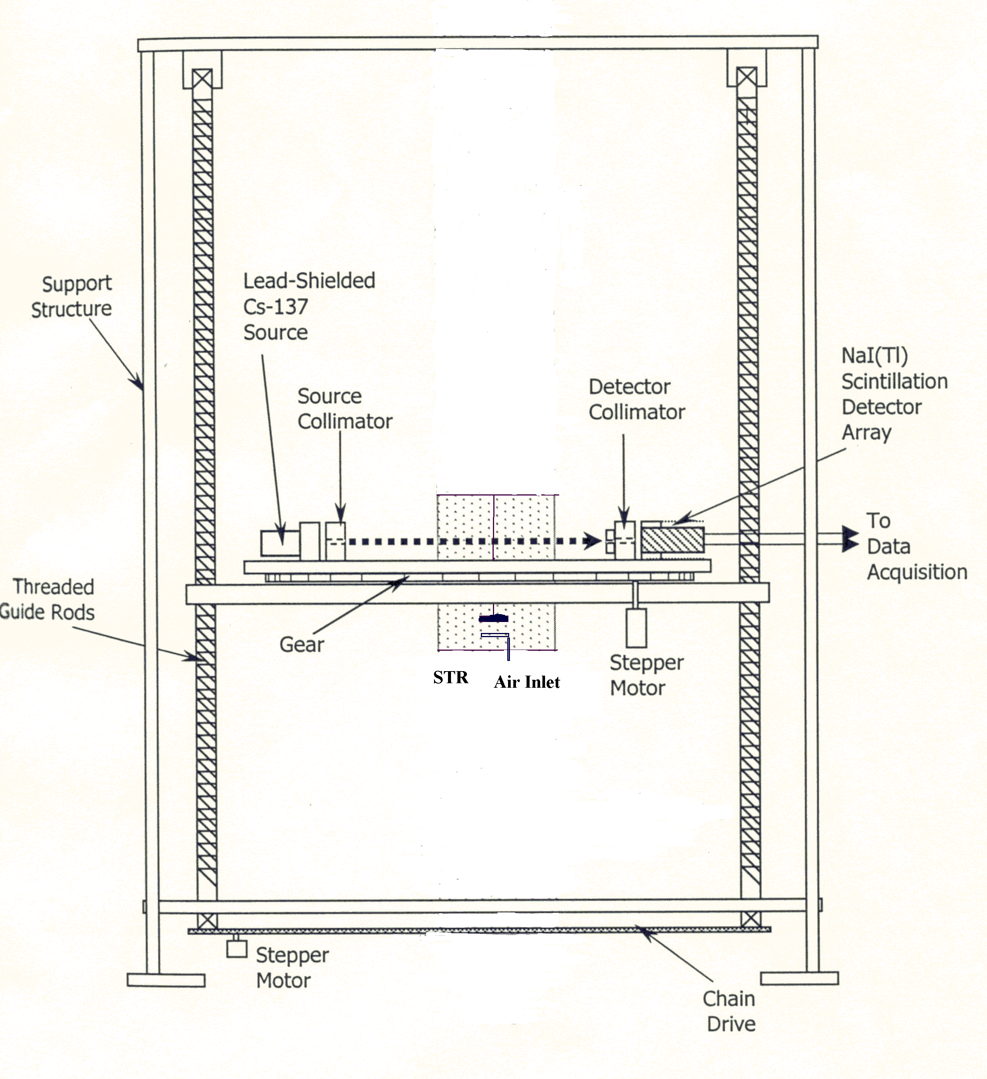
modification proposed by Kumar (1994) has been used to acquire 14 independent projection measurements per detector, which allows for a considerable improvement in spatial resolution at a minimal cost (as low as 2.0mm). In the current study the collimator slots have a width of 3.0 mm as against 6.0 mm used earlier (refer Figure 7-12). This reduction in collimator slot width enables us to use smaller pixel sizes (since smallest pixel size ~is equal to slot width). This also helps in better spatial resolution. During the data acquisition process, with the source switched on, the stepper motors control the motion of the rotating gantry in 99 positions spanning the 360º around the column. For each such “view”, the detector collimator moves 14 steps (and is then brought back to its original position) so as to acquire 14 independent projections for each detector per view. Thus, for the stirred tank reactor for which seven detectors are sufficient to span the fan beam, a total of 9702 projections were acquired (14 X 7 X99). This with further spatial interpolation allows a final spatial resolution slightly less than 3.0 mm (the collimator slot width). The total scanning time, over which the holdup distribution is thus averaged, is a little over three hours.

Figure 7-10. Schematic Diagram of the CREL Computer Tomography Scanner with the STR Installation (Front View)

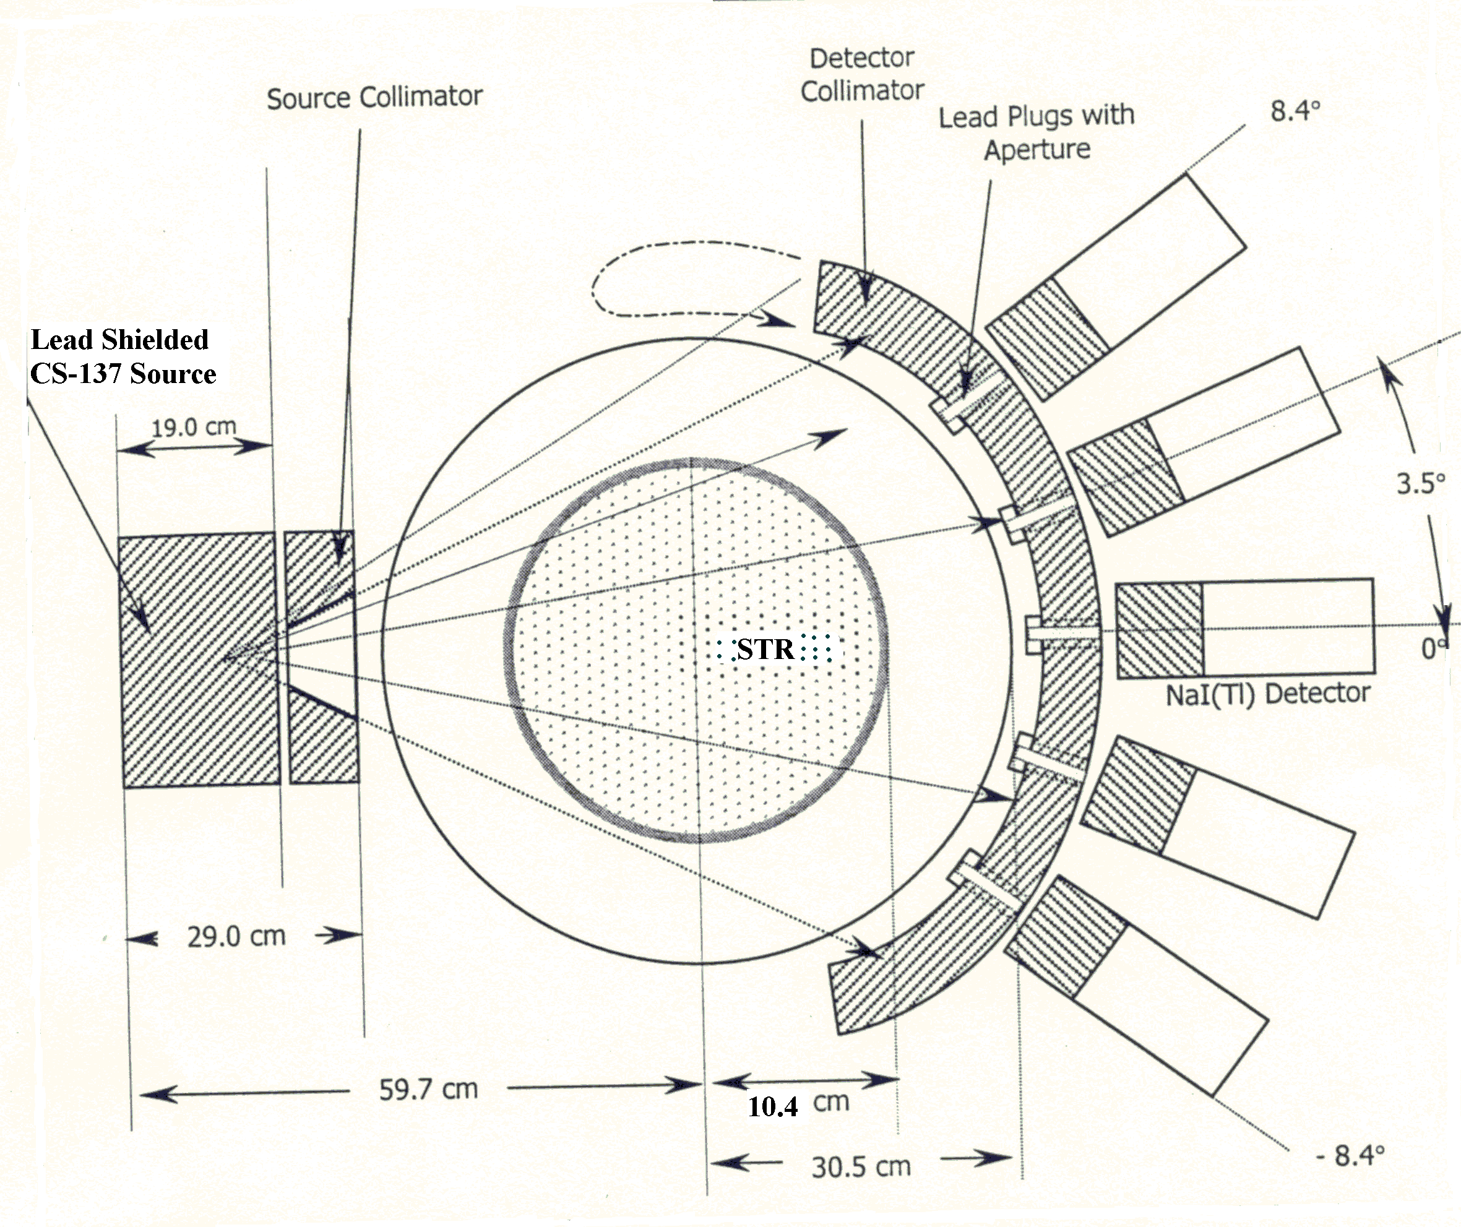

Figure 7-11. Schematic Top View of the CREL Computer Tomography (CT) Scanner with the Stirred Tank Installation, at One Specific Location of the Gantry Plate (Note that Dimensions and Angles are not to Scale and have been Exaggerated for Clarity)

The photon count data was acquired by using a threshold of 420mV which ensured that only the photo peak photons were collected and not the entire spectrum as was done earlier. The basis for doing this has been explained in Chapter 5. The adjusted spectra of the seven detectors is shown below in Figure 7-13.

Collimator in front of detector
3 mm

Figure 7-12. Details of New Collimator Used for Current Study

Th₁=36 mV
Th₂=420 mV

Figure 7-13. The Adjusted Photoenergy Spectrum of the Radiation Emitted by Cs¹³⁷ Received by the Seven Detectors

For image reconstruction the EM algorithm is used (refer to section 7.2.9), the implementation of which has been discussed in detail by Kumar (1994), and Kumar and

Dudukovic (1997). In order to ensure equivalent convergence of the different reconstruction cases (corresponding to changes in impeller speeds and gas flow rates) an internal convergence criterion has been defined as:
$\text{Re}s_{N+1} = \sum_{i=1}^{\text{Npix}}{{\left(α_{i}^{N+1}−α_{i}^{N}\right)}^{2}}$ (7-29)
where $\text{Re}s_{N+1}$ is the residual at the N+1 iteration, $α_{i}^{N+1}$ is the value of the holdup in the ith pixel at the N+1 th iteration. This definition of the residual ensures that the difference in holdup in each pixel between the N+1 th iteration and Nth iteration reaches a certain minimum value predefined by the user. This criterion enables an automatic selection of the number of iterations required for the EM algorithm to converge. This simple criterion replaces the earlier procedure where the number of iterations for convergence was arbitrarily defined as 10-20 and ensures that the reconstructed images are all equally converged.

The CREL scanner currently has a spatial resolution of ~2-3 mm and a density resolution of 0.04 gm/cm³ (Kumar, 1994). Radiation safety considerations limit the use of stronger source strengths, thus we need to acquire data for longer times which coupled with the other factors mentioned earlier limit the temporal resolution of the setup.

    - Sources of Errors in CT Measurements

A detailed analysis of the different sources of errors in CT measurements have been provided by Kumar (1995). Here a brief list of the errors and their importance is described. A detailed numerical analysis of one of the sources of errors is also provided.
The possible sources of errors in CT measurements are:statistical uncertainty in photon counts, system drift, Compton scattering effects, beam hardening effects, data sampling frequency in space, dynamic bias or void fluctuation effects, uncertainties due to the temporal structure of the flow and errors in the image reconstruction process. The issue of uncertainty in photon counts has been discussed in Chapter 5 and the error is kept to a minimum by sampling for a long enough time which ensures that the normalized variance

is negligible. System drift contribution was found to be minimal. The Compton scattering effects have no effect on the current study since only the photo-peak fraction of the total energy spectrum is acquired. Kumar (1994) indicates that emissions associated with single photopeak the beam hardening effects are negligible. The effect of frequency in space, dynamic bias and temporal structure of the flow can all be combined into one single “dynamic bias” error. This error is discussed in detail in Appendix A and a numerical model has been developed to quantify the maximum values of this error. The study revealed that this error is typically of the order of 1% for conditions of our interest.

    - Details of the Stirred Tank Set-up
We use the same stirred tank in which the single phase experiments were executed (refer to Chapter 3). To the existing set-up made modifications were made, which allow us to study gas–liquid flows. Lu and Ju (1987) used a ring sparger of diameter equal to 0.3T (T is tank diameter). The sparger consisted of a steel tube (dia = 0.02T) and holes (dia=0.007T, spacing=0.075T, 4 #’s) are drilled on the tube. Our set-up follows their scaling relations. The details of our sparger are shown below in Figure 7-14:
Top View of
Sparger
φ = 0.635 cm
6.66 cm
8 holes, φ =0.15 mm
0.02T
0.075T

Sparger

Screw used to adjust
height of
sparger
above bottom of tank

Gas Inlet pipe connected
Gas Inlet
to compressor

Figure 7-14. Details of Sparger Design

The sparger is made of clear plexi-glass. This configuration requires the least amount of modification to the existing system and is also the best from the point of view of having least interference from internals inside the reactor both for CARPT and CT. The sparger at the bottom causes much lesser disturbance to the CARPT and CT system than if we were to have a pipe running parallel to the axis and the ring sparger below the impeller. The details of the set-up with the sparger inside the tank is shown below in Figure 7-15.

Figure 7-15. Details of the Stirred Tank Set-up Used for Gas –Liquid Studies

    - Experimental Conditions
Two dimensional time averaged gas holdup distributions in horizontal planes were measured at three different axial levels (5.0, 10 and 15 cm), at four different rpms (100, 150, 200 and 400) and at four different gas flow rates (0.5, 2.5, 5 and 7.5 l/min) which correspond to flow numbers in the range of 0.01-0.50. A flow regime map corresponding

to our data has been prepared along the lines of Bombac et. al. (1997) (refer to Figure
7-3). The map helps us to appreciate the flow regimes to which the different data points are expected to belong. From the map it can be seen that three data points belong to the vortex clinging cavity regime (VC), three belong to the S33 structure and a large number of the data belong to the regime between the Ragged cavity structure and the bubble column like regime. This is a limitation of the current data set that not much data is present in the fully established circulation regime which is typically of industrial interest. This limitation was largely due to the issue of dynamic bias of CARPT technique (refer Chapter 5, Section 5.2) at higher impeller speeds.

  - Results and Discussion
In order to test the ability of the CT set-up to capture the internals of the stirred tank reactor a scan of the empty vessel was performed with just the tank and then with the tank with internals i.e. baffles and impeller. The reconstructed holdup distribution of the glass internals in the tank is shown below in Figure 7-16.
6 blades of Rushton Turbine, 1.5 mm thick
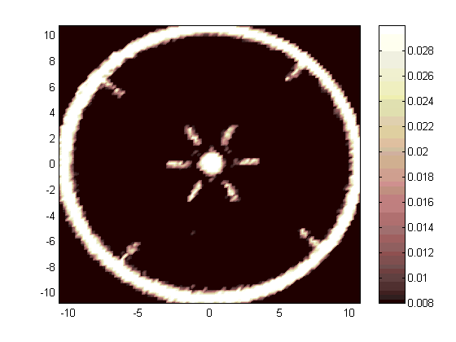
S.S. Shaft φ=0.81 cm
4 Baffles
(1.5 mm thick)

Figure 7-16. Reconstruction of Internals of the Stirred Tank Reactor

From the above Figure 7-16 it can be seen that CT can reconstruct the internals faithfully. This is very good considering the fact the blades and the baffles are as thin as 1.5 mm. The Figure 7-16 also shows that CT can clearly identify the four baffles and the six blades of the Rushton turbine. The presence of stainless steel shaft is also clearly seen as a hole of 0.81 cm diameter. Figure 7-16 also reveals that the impeller is centered perfectly in the tank.

A further test to check the ability of the CT setup was to take a scan of the axial plane above (1.67 cm) the sparger plane at very high gas flow rate (Q₄=7.5 l/min) and impeller speed of 100 rpm (N₁) corresponding to Fl=0.253 and Fr=0.019 (bubble column like regime from Figure 7-3). Under these conditions we expect to see jets of gas coming from the sparger holes. The CT scan obtained under these conditions has been processed to yield the gas holdup distribution which is shown below:
Gas Jets from Sparger with 8 holes

Figure 7-17. CT Scan of the Plane Just Above the Sparger (Z=5.0 cm, Z/T=0.25)

Figure 7-17 shows accumulation of gas in eight clear circles distributed axisymmetrically around the center. The diameter of these circles is approximately 1.0 cm. The radius of the circle along which these smaller circles lie is ~3.3 cm. The location of the gas pockets and the diameter of the circle along which they are distributed clearly shows that these pockets correspond to the eight jets of gas coming from the eight holes on the sparger. The radius of the sparger is 3.33 cm which confirms that these jets are indeed the gas from the sparger. The diameter of the holes on the sparger are of course much smaller, but it is to be expected that at such high velocities the diameter of the jet will increase rapidly with distance from the point of entry due to inertial effects.
The above tests suggest that the CT data collected in the stirred tank reactor can be expected to be reasonably accurate. In the following section further qualitative analysis of the CT data is provided.

    - Qualitative Analysis of Gas Holdup and Velocity Distributions

      - Analysis of Gas Holdup Distributions in the Stirred Tank Reactor

7.4.1.1.1 Analysis of Contours of Gas Holdups
There are fifty different data points from the CT experiments of which one select condition (of the three conditions at which CARPT data are available) is discussed below. The rest is shown in Appendix C. The figures that follow show the gas holdup distributions in the different axial planes in the stirred tank reactor. The figures are analyzed for the distribution pattern of gas and possible asymmetries in the distribution of gas. In the figures below the gas holdup distribution at three different axial planes at Fl=.112 and Fr= 0.042 (Ragged Cavity regime) is discussed. In general, for each condition the gas holdup at the highest axial plane i.e. Z=15cm (Z/T=0.75) is lower than the holdup values found in the other two axial planes. At the lowest plane i.e. Z=5 cm (Z/T=0.25) a ring of gas can be seen with a radius of around 3.3 cm (black circle marked region A in Figure 7-18a). This ring obviously corresponds to the region of gas jetting from the sparger. For a fixed gas flow rate an increase in impeller speed increases the

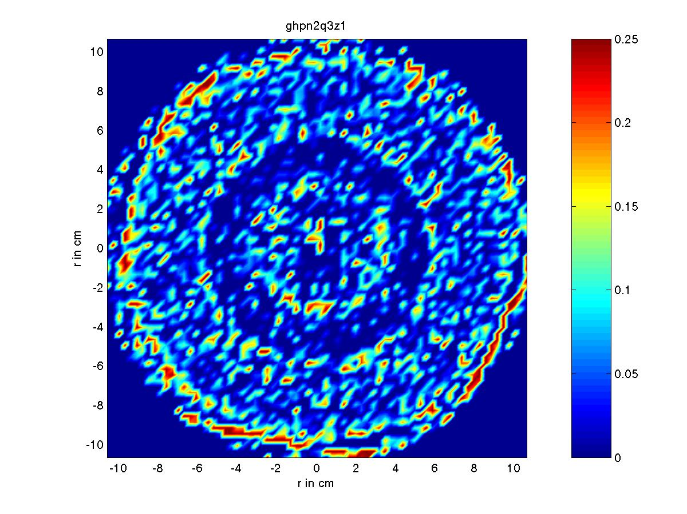
amount of gas found in this region A (due to greater gas dispersion) while an increase in gas flow rate for fixed impeller speed seems to result in the gas being concentrated more within the circle of radius 3.3 cm.
A
B
C

Figure 7-18(a). Gas Holdup Distribution at Fl= .112, Fr= .042 (N=150 rpm, Q=5.0 l/min) and Z=5.0 cm (Z/T=0.25)
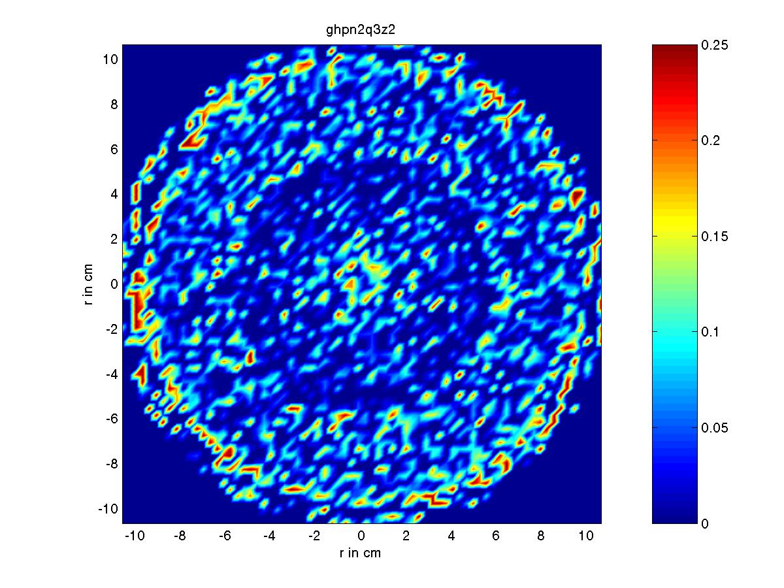

Figure 7-18(b). Gas Holdup Distribution at Fl= .112, Fr= .042 (N=150 rpm, Q=5.0 l/min) and Z=10.0 cm (Z/T=0.5)

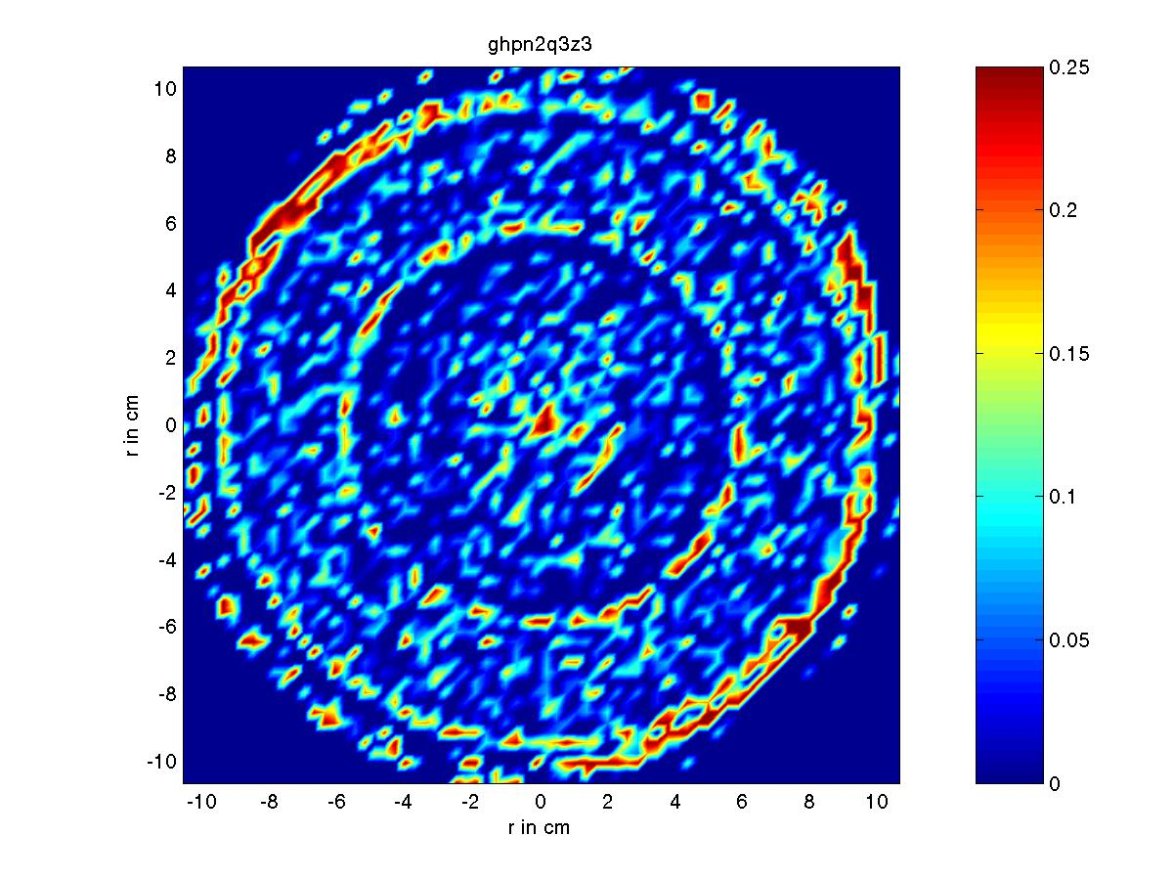
The gas holdup in the outer ring seems (region marked C in Figure 7-18a) unchanged at the different conditions in the lowest axial plane. At the central plane z=10 cm (Z/T=0.5) two zones exist, a central ring and an annular ring. At this plane as expected the sparger effect is not felt. The central ring probably corresponds to the stream of gas either rising like in a bubble column or the gas being brought down by the liquid being drawn into the impeller region.

Figure 7-18(c). Gas Holdup Distribution at Fl= .112, Fr = .042 (N=150 rpm, Q=5.0 l/min) and Z=15.0 cm (Z/T=0.75)

The gas in the outer ring probably corresponds to the gas rising up either with its terminal velocity or being dragged up by the liquid. In the central plane, for a fixed impeller speed, increasing the gas flow rate seems to increase the gas holdup in the outer ring and a decrease in the gas holdup in the inner ring. This would suggest that the gas seen in the central region is more probably due to the gas being drawn into the impeller region by the liquid than the gas rising up like in a bubble column. At the highest axial plane Z=15 cm (Z/T=0.75) the behavior is similar to the central plane although at a fixed impeller speed the gas in the central portion remains the same but the amount of gas in the outer ring increases. In all the above cases the gas is seen to be distributed axisymmetrically. The

above analysis shows that CT data is capable of providing a wealth of information which can help in both visualizing the flow structures and as will be seen below in quantifying the flow field in the presence of gas.

        - Variation of Average Gas Holdups with Impeller Speeds and Gas Sparging Rates

In this section from the CT data global average of the gas holdup is computed and the variation is plotted with impeller speeds and gas sparging rates. The global average is obtained by axially averaging the value of gas holdup obtained earlier at the different elevations of Z/T=0.25, 0.5 and 0.75 respectively.
Figure 7-19(a). Variation of Overall Gas Holdup with Gas Sparging Rate at Different Impeller Speeds

The overall gas holdups for the conditions studied are seen to be very low with the maximum overall holdup being slightly less than 2.0%. It must be mentioned that since CT data was available only at three axial planes the measure of overall holdup is may not

be very accurate. Hence we present this data in the qualitative section to show that even with the limited data the global overage obtained from CT follows the expected trends. Figure 7-19(a) shows that with increase in gas flow rate the overall gas holdup increases. At low gas sparging rates (i.e. less than 2.5 l/min) the overall gas holdups at different impeller speeds are pretty close to each other. It is beyond the gas sparging rate of 2.5 l/min that with increase in impeller speeds the gas holdups get higher. Even for this case the average holdups for impeller speeds between 100-200 rpm are very close to each other. It is only at 400 rpm that a distinct increase in the gas holdup can be seen for the higher gas sparging rates. This clearly shows that CT can capture the right trends for variation of overall holdups. In Figure 7-19(b) we plot the variation of overall gas holdup from CT with Fl. Here we compare the measured variations of overall gas holdup with the values predicted by the correlations of Hassan and Robinson (1977), Matsumara et. al. (1977) and Barigou and Greaves (1987).
Figure 7-19(b). Comparison of Overall Holdup from CT with Predictions of Correlations

Both Hassan and Robinson (1977) and Matsumara et. al. (1977) performed experiments in tanks of dimensions comparable to that used in the current study while Barigou and

Greaves performed experiments in a tank five times the size of the tank used in this study. However, Barigou and Greaves (1987) account for variations in scale of the system. Figure 7-19(b) shows that the overall holdup obtained from CT is banded between the results Matsumara et. al. (1977) and the correlations of the other two researchers. At low Fl the predictions from Matsumara et. al. (1977) are much higher than those obtained with CT. The figure 7-19(b) suggests that CT predicts overall gas holdups which are comparable to those predicted by the correlations.

      - Analysis of Liquid Velocity Distributions obtained with CARPT
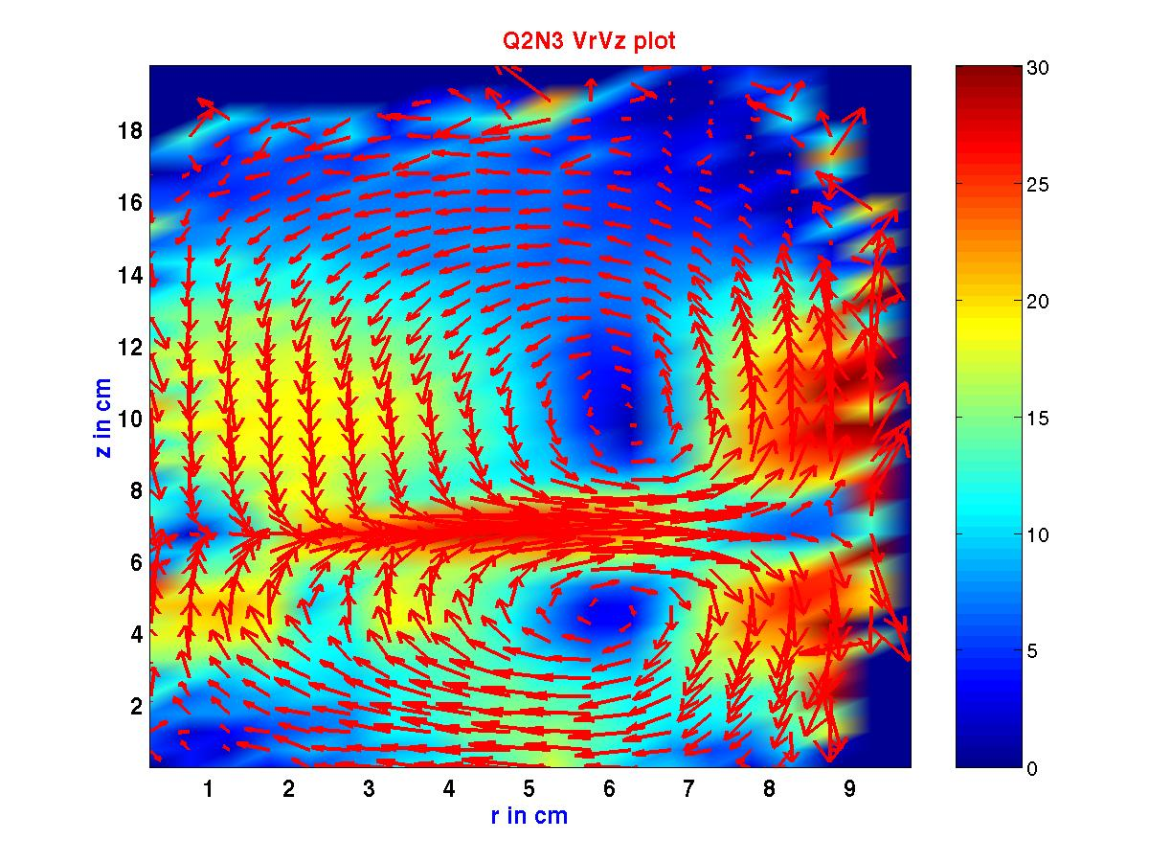

Figure 7-20. Azimuthally Averaged V_{r}-V_{z} Plot at Fl=0.042 and Fr = 0.0755 (N=200 rpm, Q= 2.5 l/min, S33 regime)

The azimuthally averaged velocity vector plot in the r-z plane at Fl=0.042 and Fr=0.0755 (N=200 rpm and Q=2.5 l/min) is shown in Fgure 7-20. The plot shows the classical recirculating flow structure seen in the single phase flow in stirred tanks. The figure is

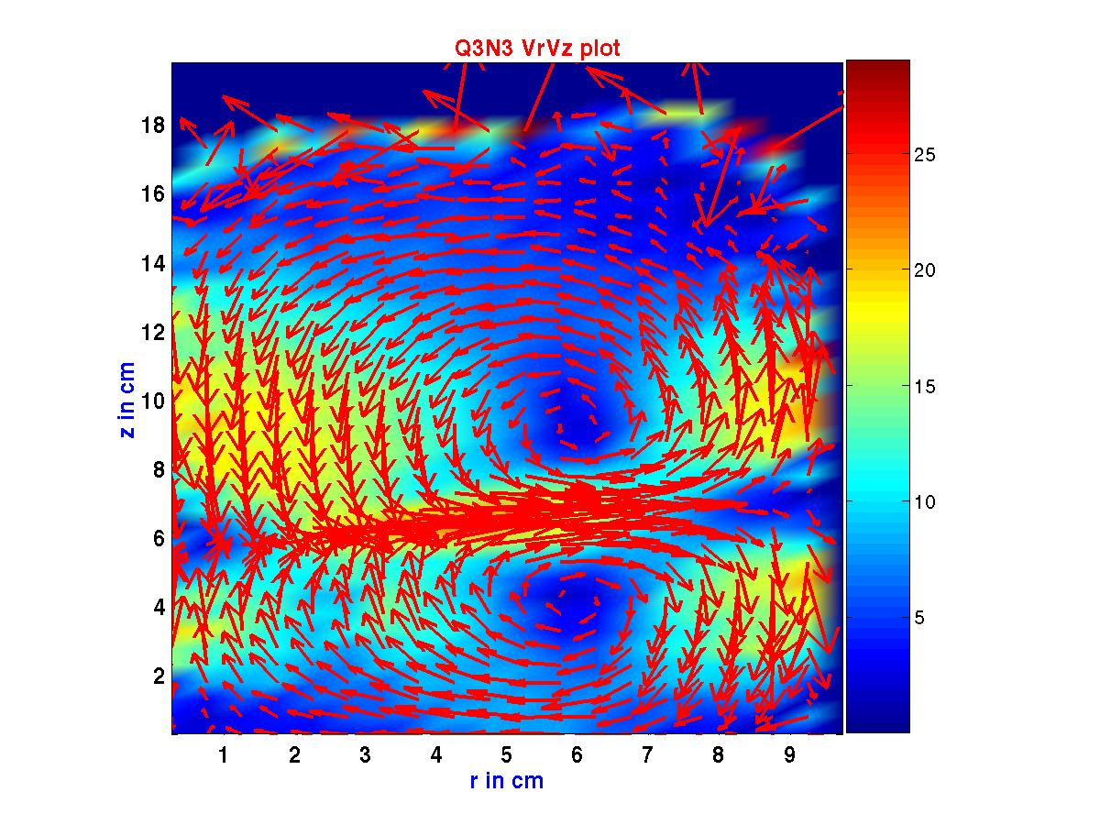
colored by contours of the magnitude of the velocity vectors in this plane. The impeller region is seen clearly by the radial jet emerging from the impeller. The radial jet, however, unlike in single phase flow does not extend all the way up to the wall. The jet seems to extend at least up to 8.0 cm which is 0.4T (T is tank diameter). The velocity vectors near the wall region and the top of the reactor are not seen clearly due to small tracer particle occurrences in those regions. The recirculating structures are characterized by two loops. The upper loop has a recirculating region of height ~ 4 cm from H=8 cm to H=12 cm with the center of the loop around 10 cm, i.e. height of the loop is 0.2T and extends from 0.4H to 0.6 H. The upper recirculating structure extends radially from ~5 –7 cm, i.e. 0.25T to 0.35 T with the center around 6 cm i.e. 0.3T. The radial jet is not any more horizontal but is inclined at some angle to the horizontal pointing upwards. The lower recirculating loop has a smaller height but the radial location is similar to the upper loop. The height of the lower loop is ~2 cm i.e. 0.1T and is half the height of the upper loop.

Figure 7-21. Azimuthally Averaged V_{r}-V_{z} Plot at Fl = 0.084 and Fr = 0.0755 (N=200 rpm, Q= 5.0 l/min, RC regime)

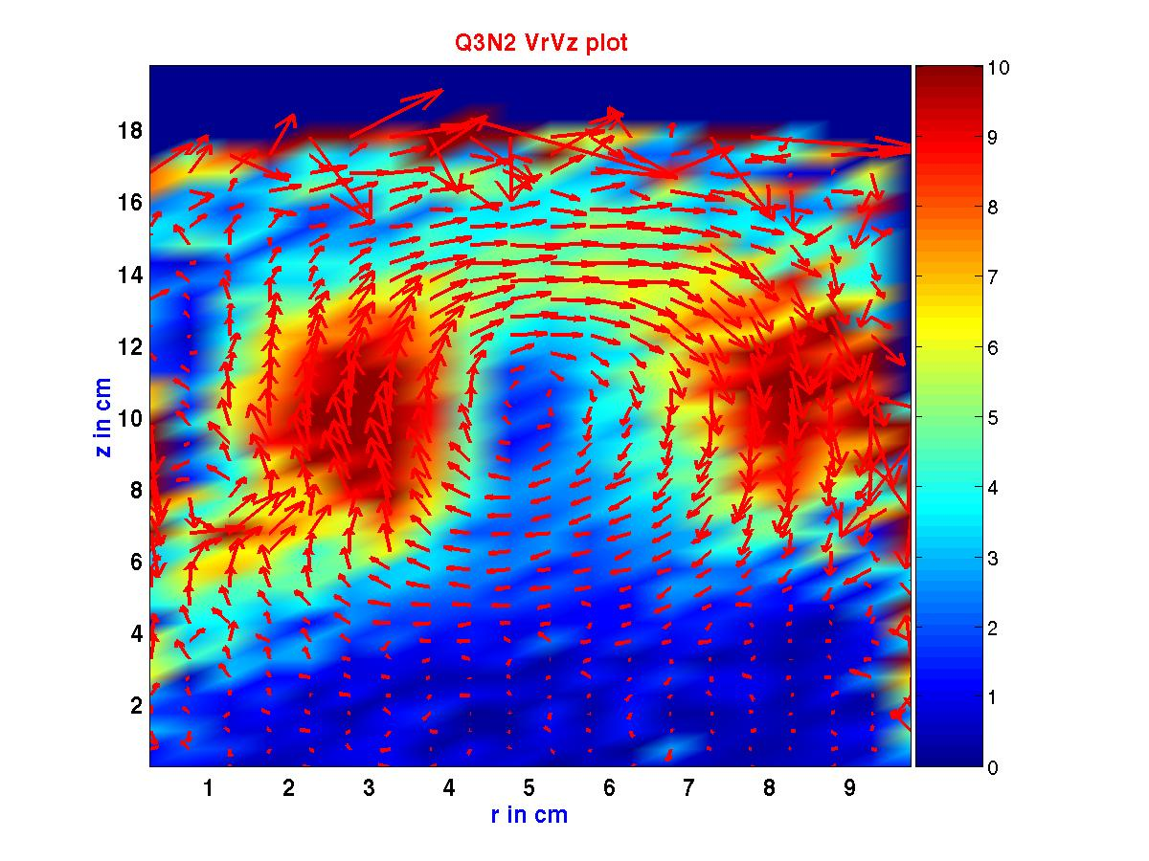
The azimuthally averaged projection of the velocity vector in the r-z plane at Fl=0.084 and Fr= 0.0755 (N=200 rpm, Q= 5.0 l/min) is shown in Fgure 7-21. The plot shows the classical recirculating flow structure seen in the single phase flows in stirred tanks. The figure is colored by the magnitude as in Figure 7-20. The general characteristics of the flow under this condition is very similar to that seen in Figure 7-20. The length of the radial jet is seen to be slightly shorter than in Figure 7-20 with the jet extending up to 7.0 cm i.e. 0.35T while earlier it had extended uptp 0.4T. The upper recirculating loop is smaller in height than the one seen in Figure 7-20. The height is ~2.0 cm which at 0.1T is half the height of the earlier loop. The center of the upper loop has also moved down to 9.0 cm i.e. 0.45T. The radial width of the upper and lower loops remain the same. The reduction in the size of the upper loop can be explained by the fact that the increase in the gas sparging rates lower the liquid velocity coming out from the impeller. Hence, when the liquid encounters the wall and starts rising up, due to the lower velocity it can not go as high as it could earlier. This causes the liquid to fall back earlier and therefore the recirculation into the impeller region is seen to begin much earlier. A similar reasoning explains the reduction in the length of the radial jet as well.

Figure 7-22. Azimuthally Averaged V_{r}-V_{z} Plot at Fl = 0.112 and Fr = 0.042 (N=150 rpm, Q= 5.0 l/min, RC regime)

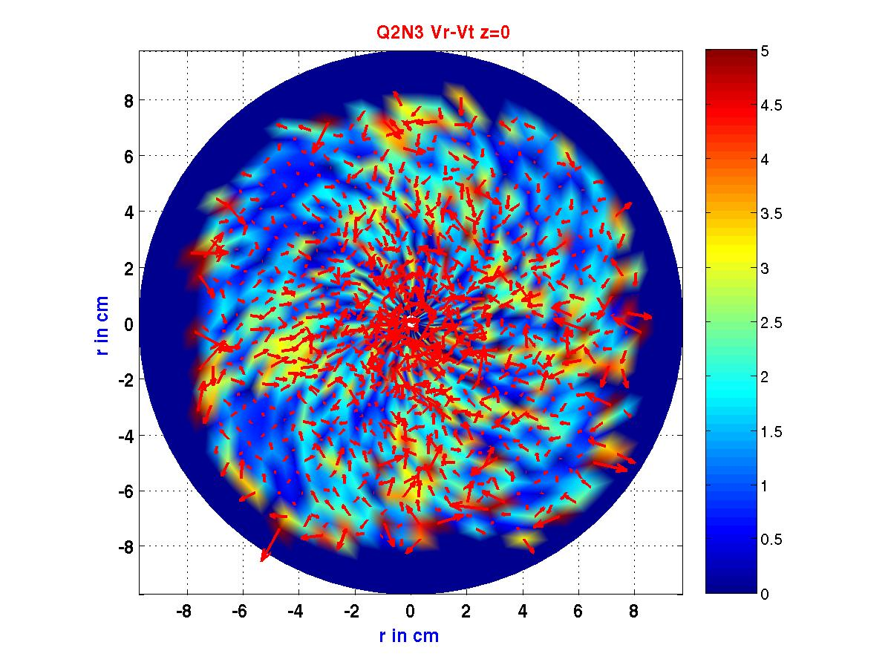
From the flow regime map (Figure 7-3) it can be seen that two of the CARPT data points belong to the Ragged Cavity regime (Figures 7-21 and 7-22) with one (Q3N2) being closer to the bubble column like regime (Figure 7-22) and the third one is on the transition between Ragged cavity and S33 structure (Figure 7-20). This partially explains the velocity vector plot in the r-z plane we see in Figure 7-22. The figure shows that under these conditions of gas sparging rates (Fl=.112 and Fr=0.042) the influence of the impeller is greatly diminished. None of the classic flow structure elements are seen except for the presence of a recirculating loop which is more characteristic of bubble column like flows. The direction of the liquid flow is totally opposite to that seen in the earlier two figures(7-20 and 7-21) as now at the impeller plane the liquid is flowing radially inward while near the top the liquid is flowing radially outward. This flow structure is akin to the flow structure expected in a bubble column. The upper loop has dimensions similar to the upper loop seen in Figure 7-20. The height is the same and the radial width is the same. However the radial location is shifted inward by 1.0 cm (0.05T).

Figure 7-23. Azimuthally Averaged V_{r}-V_{θ} Plot at Fl = 0.042 and Fr = 0.0755 (N=200 rpm, Q= 2.5 l/min, S33 regime) at Z=0 cm (Z/T=0)

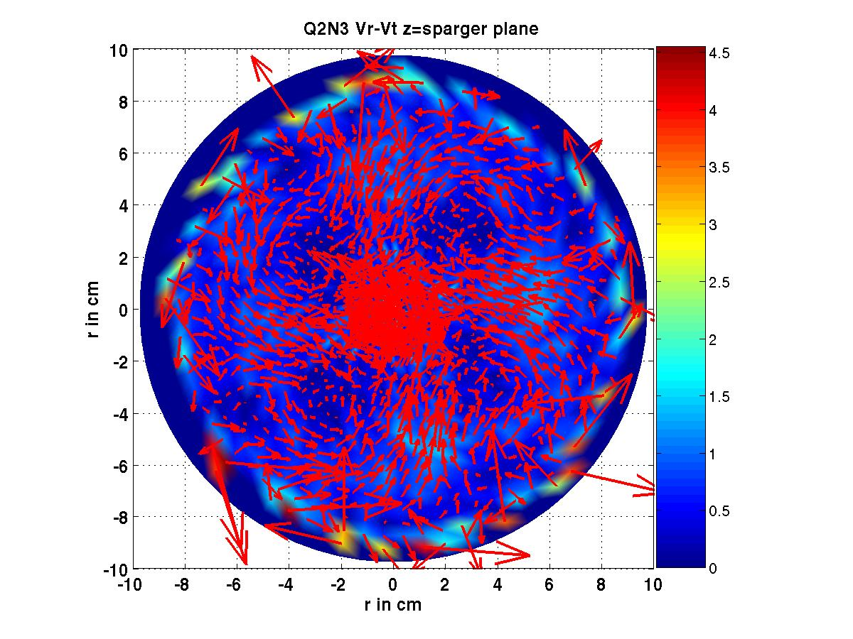
The velocity vector projection plotted in the axial plane corresponding to the bottom plane is shown above in Figure 7-23 at Fl=0.042 and Fr=0.0755 (N=200 rpm, Q= 2.5 l/min, S33 regime). The flow pattern is very different from the flow pattern seen for the single phase case (Refer Chapter 3) where a starfish like pattern was observed with clear zones of high liquid velocity sorrounding zones of low velocity.

Figure 7-24. Azimuthally Averaged V_{r}-V_{θ} Plot at Fl = 0.042 and Fr = 0.0755 (N=200 rpm, Q= 2.5 l/min, S33 regime) at Z=4.0 cm (Z/T=0.2)

Figure 7-24 shows the distribution of the velocities in the axial plane just above the sparger. This plane shows a very interesting vortical structure of the liquid flow. There are four recirculating structures symmetrically distributed around the center. At the center is a region of high velocity. The central region is seen to have a radius of 2.0 cm. The outer boundary of the vortical structures are seen to lie along a circle of radius 4.0 cm clearly indicating that the vortical structures are due to the gas jets coming from the

sparger. In this plane the tangential flow is obviously stronger than the radial flow implying that the impeller influence is not very strong here except near the center. The very large velocity vectors very near the wall zone are artifacts of the technique which could not be filtered.
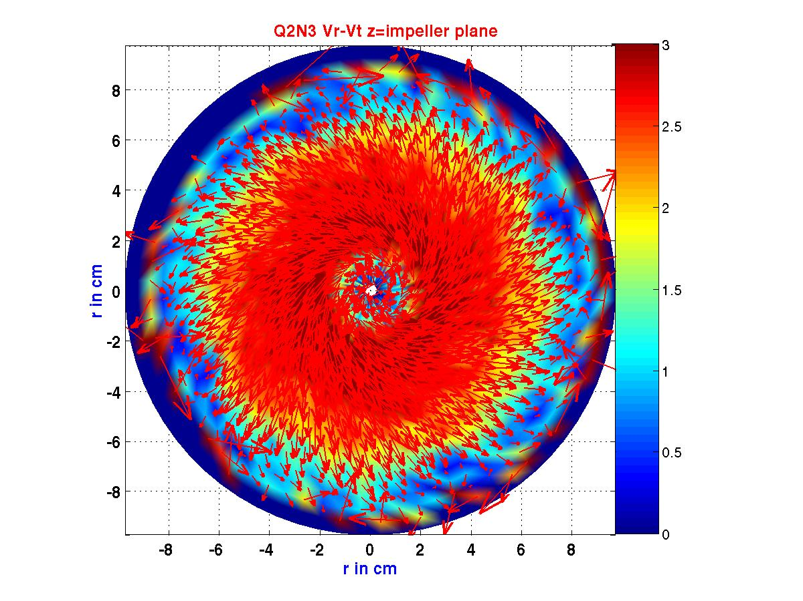

Figure 7-25. Azimuthally Averaged V_{r}-V_{θ} Plot at Fl=0.042 and Fr=0.0755 (N=200 rpm, Q= 2.5 l/min, S33 regime) at Z=6.66 cm (Z/T=0.33)

The projection of the velocity vectors in the plane of the impeller is shown above in Figure 7-25. The vector plot shows the classical radial flow emerging from the impeller. The radial flow is seen to extend up to nearly 8.0 cm which matches with the length of the radial jet seen earlier in Figure 7-20.

This completes the qualitative analysis of the data obtained with CARPT and CT for gas – liquid flows in our stirred tank. In the following sections some quantitative analysis of the CARPT-CT data is presented.

    - Quantitative Characterization of Gas Holdup Distributions and Liquid Velocity Field
      - Azimuthally Averaged Radial Gas Holdup Distributions

Detailed radial variation of the azimuthally averaged gas holdup profile is shown below in Figures 7-33 to 7-35. The figures show the variation for different gas sparging rates and at different axial locations. From the figures it can be seen that the local holdups for the current study vary from 0-26%.
Figure 7-26(a). Influence of Gas Sparging Rates on the Radial Variation of Gas Holdup at Fr=0.019 (N=100 rpm), Z/T=0.25

Figure 7-26(a) which displays the gas holdup variation in a plane below the impeller indicates a distinct pick in the region corresponding to the impeller tip i.e. ~ r/R=0.33. At Fl=0.017 there is an accumulation of gas near the shaft region and the peak for this flow rate is seen near r/R=0.2 (where the impeller blades begin). The peak is seen to shift to the impeller tip with increase in Fl at fixed Fr. For all gas flow rates there is a second distinct peak in the bulk region near r/R=0.6. This peak probably corresponds to the region where the axial velocity changes direction. A third distinct peak is seen near the wall region where the gas holdup is rather high. In the impeller region an increase in gas sparging rate is seen to cause an increase in the gas holdup with a holdup of nearly 10% at Fl=.253. In the bulk region the gas holdup at all gas flow rates except the lowest are pretty close to each other.

Figure 7-26(b). Influence of Gas Sparging Rates on the Radial Variation of Gas Holdup at Fr=0.019 (N=100 rpm), Z/T=0.5

Figure 7-26(b) shows the variation of gas holdup at Z/T=0.5 at Fr= 0.019 (N=100 rpm). In this plane there is a tendency for gas to accumulate in the region around the shaft. The influence of the impeller is not really felt in this plane. The peak in the bulk region

around r/R=0.6 is seen once again. In the bulk region the holdups seem to follow two branches: an upper branch corresponding to the two high flow rates and a lower branch corresponding to the two low flow rates. The gas holdup is seen to peak in the region near the wall. The location of the peak in the bulk is slightly inward (~0.55r/R) for the lower two flow rates while for the higher flow rates it is around 6.0 cm. The maximum holdup is around 10%.
Figure 7-26(c). Influence of Gas Sparging Rates on the Radial Variation of Gas Holdup at Fr = 0.019 (N = 100 rpm), Z/T = 0.75

Figure 7-26(c) shows the variation of gas holdup at Z/T=0.75 at Fr=0.019 (N=100 rpm). The gas holdup near the center has increased compared to the earlier two axial planes. Unlike at Z/T=0.25 the holdup corresponding to Fl=0.017 is the lowest and the holdup near the center increases with gas sparging rate. Similar to the results at Z/T=0.5 a peak is seen in the bulk region and the location of the peak region shows a similar inward shift for the lower two flow rates(which are very close to each other). Hence, qualitatively in the two axial planes Z/T=0.5 and .75 a similar trend of gas holdup is observed with the only difference being a slightly higher value of gas holdup near the center in the Z/T=0.75 plane and the maximum value of gas holdup in this plane is ~11%.

The above analysis shows that CT is capable of providing extensive local information regarding the gas holdup distributions in the stirred tank reactor. It is also seen that CT can capture both low and high values of gas holdup with ease. The CT obtained radial profiles also show the expected qualitative trends and the measures of global averages like the overall gas holdup show the right qualitative trends. There is at present no other source of such detailed local measurements which would enable a more detailed quantitative validation of the technique.

      - Liquid Velocity Distributions from CARPT

Figure 7-27 shows the radial variation of the radial liquid velocity profile at two different axial planes (Z/T=0.19 and 0.33). Figure 7-27(a) shows the radial variation at Z=3.75 cm (Z/T=0.19) which corresponds to the top surface of the sparger from which the gas jet is emerging. The radial velocity at Q2N3 (Fl=0.042, Fr= 0.0755) is predominantly radially inward (hence the negative sign). The radial velocities in this plane are low with a maximum magnitude of –5.8 cm/s. The radial liquid velocity corresponding to Q2N3 is the maximum one since impeller speed is the highest and the gas flow rate is the lowest. For the same impeller speed increasing the gas flow rate results in lowering the magnitude of the radial velocity by almost 66%. For the same gas flow rate Q3 a reduction in impeller speed from N3 to N2 (Fr=0.0755 to Fr= 0.042) makes the magnitude of the radial velocities extremely low with a maximum value of –1 cm/s. The radial liquid velocity at Q3N3 (Fl=0.084, Fr= 0.0755) turns radially inward at radial location of 2.2 cm while for Q2N3 it remains radially inward almost until r=0.75 cm (r/R=0.075). This difference in the location of the change in direction is due to the higher liquid velocity at lower gas flow rate which causes the liquid to be drawn into the impeller with greater intensity than at higher gas flow rate. Figure 7-27(b) shows the radial variation in the plane of the impeller. The radial jet causes a region of high velocity in the bulk starting from the region near the start of the impeller blade up to almost r= 5-6 cm (r/R=.5 to .6). The radial profile of the radial velocity in the impeller region looks quite different from the radial profile seen for the single phase case where the radial

velocity peaks close to the impeller tip and starts decreasing rapidly. Here the presence of gas is seen to cause the maximum value to be spread out radially. Further the maximum radial velocity for Q2N3 is only 0.387 Vtip and for Q3N3 is only 0.287Vtip which is much lower than the 0.57Vtip observed for the single phase case. Therefore sparging of gas causes drastic reduction in radial velocities.
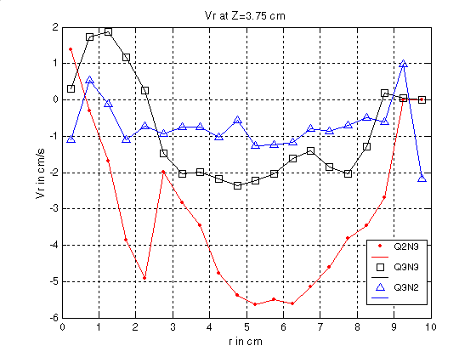

Figure 7-27(a). Radial Profile of Radial Liquid Velocity at Sparger Plane Z=3.75 cm

Increasing impeller speed is seen to clearly cause an increase in the radial velocities and for a fixed impeller speed decreasing the gas sparging rate causes an increase in the radial liquid velocity. Figure 7-28 shows the radial variation of the tangential velocity. At Z=3.75 cm (Figure 7-28(a)) the tangential velocity corresponding to Q2N3 is the highest near the center and progressively decreases away from the center. Interestingly the direction of the liquid rotation of the fluid changes sign in the bulk (~r=6.0 cm). The positive sign indicates that the direction of rotation coincides with the direction of rotation of the impeller. The change in direction of rotation occurs at r=6.0 cm both for the Q2N3 case and the Q3N3 case. This is clearly associated with the flow reversal observed at this radial location (refer to Figures 7-20 and 7-21). In the region near the

center the tangential velocity for Q2N3 is higher than the tangential velocity for Q3N3 by almost 50% and then it falls almost on top of the other in the bulk region.
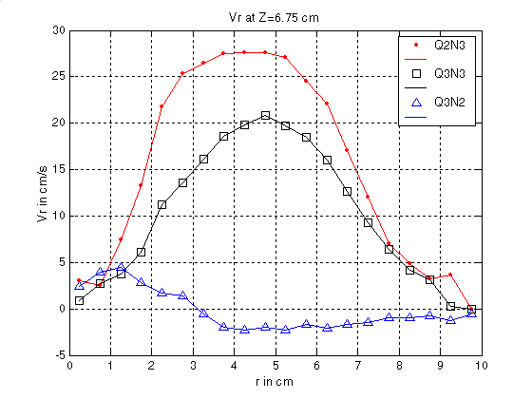

Figure 7-27(b). Radial Profile of Radial Liquid Velocity at Impeller Plane Z=6.75 cm

Interestingly the tangential velocities for the Q3N3 and the Q3N2 cases are very close to each other (less than 10%) in the central region.
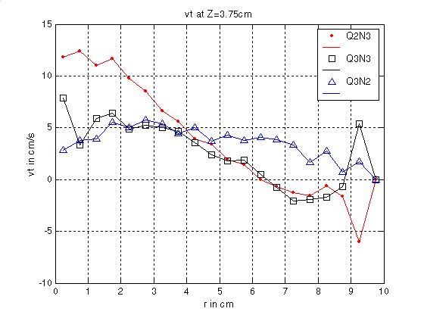

Figure 7-28(a). Radial Profile of Tangential Liquid Velocity at Sparger Plane Z=3.75 cm

Figure 7-28(b) shows the radial variation of the tangential velocity in the impeller plane. The Q3N2 case has a peak value of 0.6 Vtip while the Q3N3 case has a peak value of 0.286 Vtip. The location of the peak value is r=2.25 cm (r/R=.225) for the Q3N2 case and r=3.25 cm (r/R= 325) for the Q3N3 case. The decrease in the tangential velocity away from the impeller is similar for the Q3N3 and Q3N2 case with the curves being almost parallel to each other beyond r=5.0 cm (r/R=0.5). Between r=2.25 (r/R=0.225) to r=5.0 cm (r/R=0.5) for the Q3N2 case the tangential velocity falls more rapidly than in the Q3N3 case. The Q3N2 case, as expected, does not have a peak near the impeller tip since this is the bubble column like flow regime (refer to Figure 7-23) where the impeller action is minimal. The Q3N2 case has a peak in the tangential velocity near the center (r=1.25 cm, r/R=.125) and then the velocity falls subsequently. Beyond r=4.0 cm (r/R=0.4) the bulk liquid is not subject to any rotation in this case.

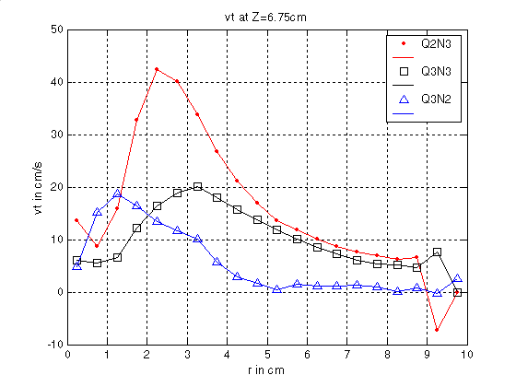

Figure 7-28(b). Radial Profile of Tangential Liquid Velocity at Impeller Plane Z=6.75 cm

The radial variation of the axial velocities is shown in Figure 7.29. These plots indicate that the axial velocities cross over from positive to negative velocities at r=6.0 cm

(r/R=0.6) i.e. from flow upward to flow downward (in the planes below the impeller) and from flow downward to flow upward (in the planes above the impeller). This along with Figures 7-20 and 7-21 indicate that this radial location corresponds to the eye of the upper and lower circulating loops. Hence these regions are associated with very low velocity which causes the gas to accumulate in the eye of these recirculating loops. Figure 7-29(a) shows the radial variation of the axial velocity at Z=3.75 cm. The axial velocities at Q2N3 and Q3N3 are 2 to 2.6 times higher than the axial velocity at Q3N2 near the center. The axial velocities at Q2N3 are 1-40% higher than the axial velocities at Q3N3. Differences between Q2N3 and Q3N3 are more pronounced near the center and the walls. The differences are much lower in the bulk region. The axial velocities for the Q3N2 fall to zero around r=3.0 cm (r/R=0.3) indicating that there is almost no flow in this region. This is also seen clearly from the velocity vector plot shown in Figure 7-23.
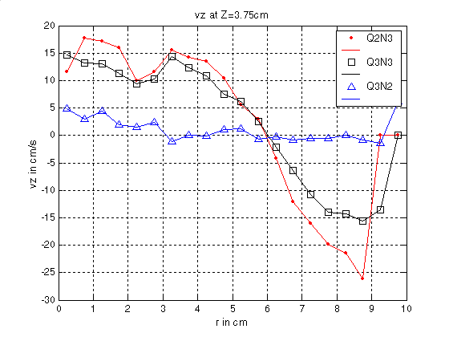

Figure 7-29(a). Radial Profile of Axial Liquid Velocity at Sparger Plane Z=3.75 cm

Figures 7-29(b) show the reversal of flow with the radial location where the reversal occurs at r=6cm (r/R=0.6). At Z=10 cm the Q3N2 case shows a peak in the upward axial velocity near the center extending from r=2 to3.75 cm (r/R=0.2 to 0.375) beyond which it

starts falling and becomes negative at r=5.0 cm (r/R=0.5). The axial velocity corresponding to Q2N3 is higher (5-20%) than the axial velocity of Q3N3. This completes the detailed analysis of the radial variation of the radial, tangential and axial velocities at select axial planes of interest in the stirred tank reactor. In the following section the axial variation of these velocity components is discussed in detail.
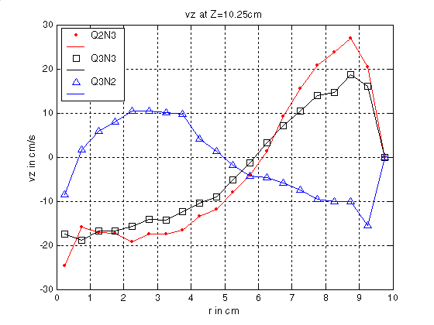

Figure 7-29(b). Radial Profile of Axial Liquid Velocity at Z=10.25 cm

Figure 7-30 shows the axial variation of the radial velocity at three different radial locations r=2.25 cm, 3.75 and 6.25 cm (r/R=0.225, 0.375 and 0.625) corresponding to regions near the start of impeller blade, impeller tip and point of flow reversal respectively. Figure 7-30(a), 7-30(b) and 7-30(c) show the influence of the impeller motion on the radial velocity. The maximum radial velocity is seen at r=3.75 cm (r/R=0.375) as expected. The radial velocity corresponding to Q2N3 is always higher (10-50%) than the velocities corresponding to Q3N3 case. As expected the Q3N2 cases shows no influence of the impeller. The axial profile of the tangential velocities (Figure 7-31) show a similar behavior as the radial velocities as seen from Figure 7-30, except for the fact that the impeller influence is not felt at r=6.25 cm (r/R=0.625). The other two inner radial locations show the impeller influence clearly and the maximum value of the

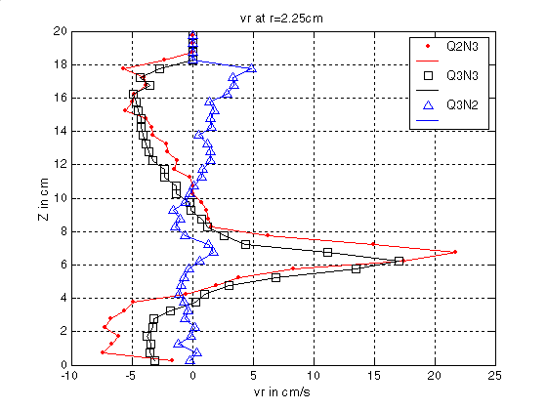
tangential velocity is seen at r=2.25 cm and not at r=3.75 cm. This behavior is to be expected and has been clearly established for the single phase case by Stoots and Calabreese (1995).

Figure 7-30(a). Axial Profile of Radial Liquid Velocity at r = 2.0 cm
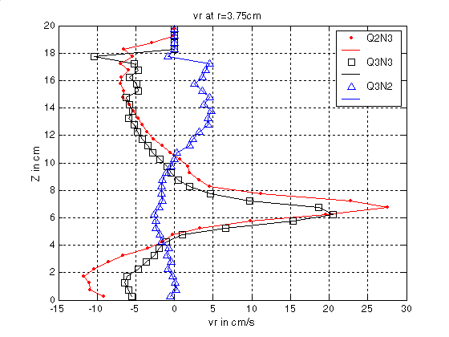

Figure 7-30(b). Axial Profile of Radial Liquid Velocity at r = 3.75 cm

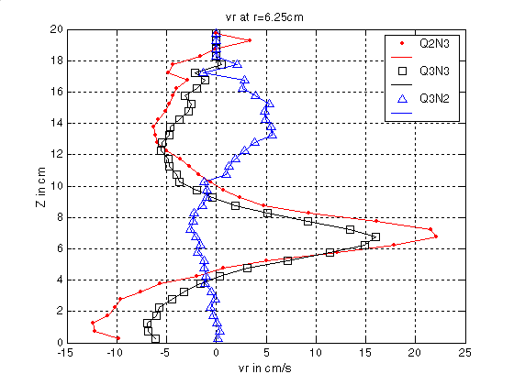

Figure 7-30(c). Axial Profile of Radial Liquid Velocity at r = 6.25 cm
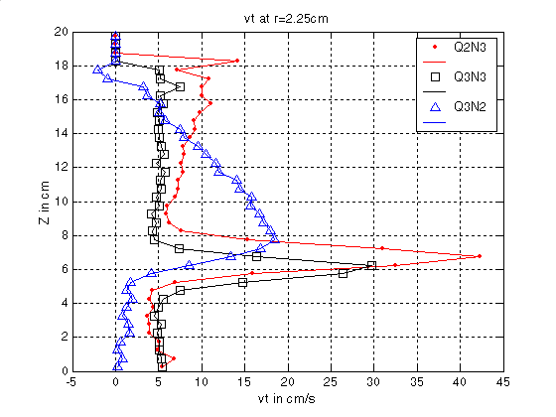

Figure 7-31(a). Axial Profile of Tangential Liquid Velocity at r = 2.0 cm
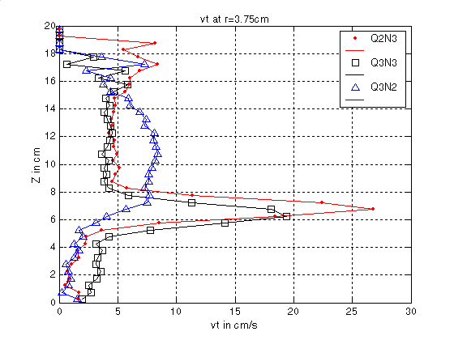

Figure 7-31(b). Axial Profile of Tangential Liquid Velocity at r = 3.75 cm

This completes the detailed analysis of the liquid velocity distributions in the stirred tank reactor in the presence of gas. The analysis reveals that together CARPT and CT data provide extensive qualitative and quantitative information regarding the nature of the gas – liquid flows. The analysis also shows that it is the combination of the two techniques which allows us to extract a more complete picture of the nature of the flow. The current limitation of lack of temporal resolution currently prevents CT from giving us information about the transient nature of the gas cavities near the impeller region.

Figure 7-32 shows the radial profile of the turbulent kinetic energy at the impeller plane. The turbulent kinetic energy for the three different conditions are comparable and the slopes are almost parallel to each other. The kinetic energy starts increasing from the center until near the wall and then it falls to zero rapidly near the wall region. The profile of the turbulent kinetic energy is similar to the profiles reported earlier (refer to Chapter 2) by Ranade and Van den Akker (1994). The non –dimensional maximum values for Q2N3 and Q3N3 are 0.74V_{tip}² and 1.35 V_{tip}² for the Q3N2 case. The profile of the turbulent kinetic energies are the same at the different axial planes and hence the detailed

profiles have not been shown here. The radial profiles of turbulent kinetic energy in the presence of gas are very different from the profiles seen with single phase flows (Refer to chapter 4).
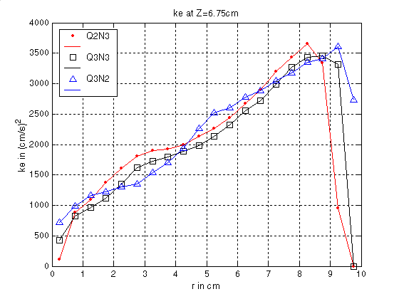

Figure 7-32. Radial Profile of Turbulent Kinetic Energy at the Impeller Plane

In single phase flows the maximum turbulent kinetic energy is typically seen near the impeller region while in the presence of gas the maximum is seen near the wall region.

  - Gas Liquid Flow Simulations via Snapshot Approach

Earlier efforts to model two phase flows in stirred tank reactors have been reviewed in Chapter 2 (section 2.4). The details of the snapshot approach are also provided in Chapter 2. The geometry and grid used for the two phase simulations are the same as those used for single phase simulations (refer to chapter 4). In the current study we use the two fluid

approach (Ishii, 1975 ; and Johansen, 1988). Drag is the only interphase term accounted for. Preliminary simulations were done with the default drag option in FLUENT and subsequently Tomiyama’s drag correlation modified by Brucato et. al. (1998) correction factor to account for background turbulence was used. This correction factor enables the prediction of lower slip between gas and liquid which helps the gas to follow the liquid more closely. In the current work we use a bubble diameter of 3.0 mm. A standard single phase k-ε turbulence model (Launder, 1983) has been used to model the primary phase turbulence. Secondary phase turbulence effects have been ignored. Boundary conditions for liquid are similar to those used for single phase simulation (refer to chapter 4). Gas was introduced through the sparger by activating the momentum source for the gas phase equations in the cells above the sparger. The gas velocity and holdup were specified such that there was an appropriate gas flow rate in the sparger region. The top surface of the reactor was modeled as an inlet (for details refer to Ranade, 2001). Gas liquid simulations were performed at a) N3Q1- impeller speed of 200 rpm, Q=0.5 L/min b) N3Q3 – impeller speed of 200 rpm, Q=5 L/min and c) N4Q1- impeller speed of 400 rpm, Q=0.5 L/min. The converged results of N3Q1 were used as initial guesses for both N3Q3 and N4Q1 case. Below we present some preliminary results.

    - Results and Discussions

Typical velocity vector plots of the gas and liquid phase are shown below in Figures 7-33a and 7-33b at conditions N3Q1 and N3Q3. Figure 7-33(a) shows that for the N3Q1 case the liquid velocity vectors resemble the single phase recirculating flow structure characterized by a radial jet in the impeller region and two recirculating loops above and below the impeller. According to Figure 7-3 this condition corresponds to the vortex clinging cavity regime and the Fr number is high enough for it to have more than limited recirculation but less than complete recirculation of the gas phase. However, a look at the gas phase velocity vectors suggests that there is negligible gas recirculating and most of the gas just rises up through the center of the column. This would suggest that the interfacial slip velocities between gas and liquid are high probably because the drag

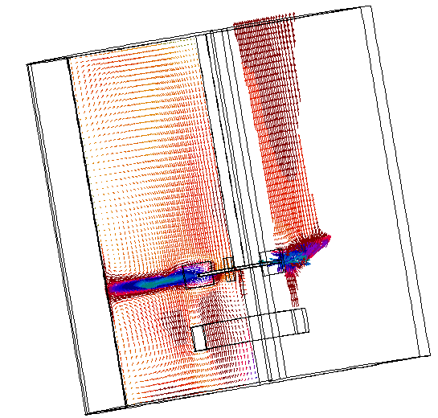
coefficient is being underestimated. Figure 7-33(b) shows the liquid and gas phase velocity vectors corresponding to the N3Q3 (bubble column like regime, Figure 7-3, Chapter 7). This figure qualitatively looks similar to the Figure 7-22 (Chapter 7) but here the impeller is still seen to be effective. In Figures 7-34(a) and 7-34(b) the contours of turbulent kinetic energy and holdup are shown at N3Q1 and N3Q3, respectively.

Figure 7-33(a). Predicted Flow Field for N3Q1 Case. Left: Vectors of Liquid Phase; Right: Vectors of Gas Phase
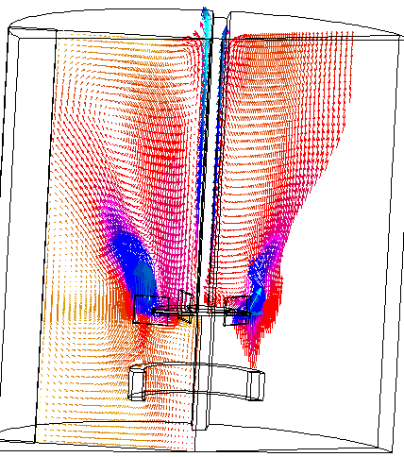

Figure 7-33(b). Predicted Flow Field for N3Q3 Case. Left: Vectors of Liquid Phase; Right: Vectors of Gas Phase
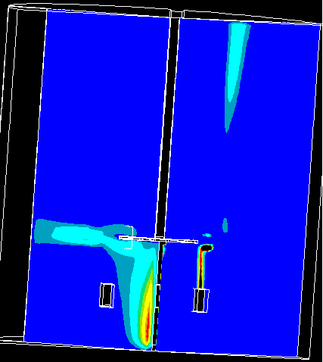

Figure 7-34(a). Predicted Flow Field at N3Q1. (Left: Contours of Turbulent Kinetic Energy; Right: Contours of Gas Holdup). Ten Uniform Contours Maximum Value = 0.1(Black) and Minimum Value = 0 (Blue)
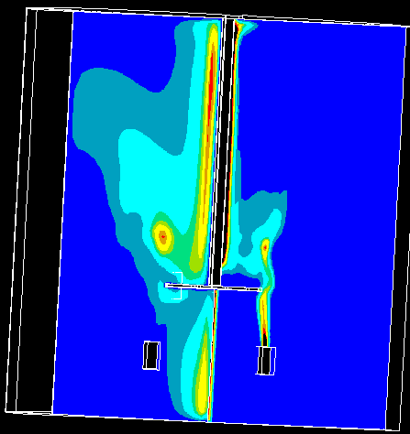

Figure 7-34(b). Predicted Flow Field at N3Q3. (Left: Contours of Turbulent Kinetic Energy; Right: Contours of Gas Holdup). Ten Uniform Contours Maximum Value = 0.6(Black) and Minimum Value = 0 (Blue)

The above figures suggest that the flow pattern predicted by CFD is itself vastly different from that obtained with CARPT. CFD predicted liquid velocities are different both in magnitude and in qualitative trends, from CARPT measured values which allows little scope for comparison. It was not possible to compare the gas holdup profiles from CFD with CT since CFD predicts very low values (0.0005 to 0.01) of the gas holdup and in regions away from the impeller predicts that negligible gas is present (unlike CT, refer to Figure 7-26).

The problems in the current simulation could be due to the following reasons:
- Use of Incorrect Drag Formulation: Lane et. al. (2000) indicated that using a lower value of drag correction factor may have worked for their case but also caution that it cannot be really generalized. Preliminary calculations performed with the default drag correlations in FLUENT suggested that the gas holdup pattern is extremely sensitive to the drag correlation used.
- Account for Secondary Phase Turbulence: The fact that the turbulent kinetic energy profiles are vastly different and the CFD predictions are orders of magnitude lower suggest that we may need to account for the influence of the secondary phase turbulence.
- Role of Boundary Conditions: In the current study we set the top liquid surface as an inlet and set the liquid velocity to be zero and that the gas rises at its terminal rise velocity of 20 cm/s. It is not clear if this is influencing the quality of the predictions. In the current study since we started with a very fine grid it was not possible to systematically inspect the role of boundary conditions and the role of drag by trying different combinations of these. A major problem faced in the current work was that the time taken for convergence for one condition was extremely long which allowed little opportunity to change conditions and rerun these cases.
- Use of Single Bubble Size: In the stirred tank reactor given the range of turbulence scales present, and the different forces present in different regions of the tank it is to be expected that there will be a distribution of bubble sizes. The

drag coefficients calculated in each region depend on the bubble size. Smaller bubble sizes cause the drag coefficients to be higher and therefore will predict smaller slip between gas and liquid. Therefore, using one single bubble size may also introduce considerable errors in the simulation unless of course a drag correlation independent of bubble size is used and shown to have reasonable predictions.

The current study clearly indicates a need to repeat the exercise using a much coarser grid than used for the current study and systematically examine the influence of various different parameters on the sensitivity of the predictions of this approach. The current work also clearly indicates that CFD in two phase stirred tanks is still in its early stages needing a lot more work in terms of development of physics based models.

  - Conclusions
A detailed analysis of of data obtained by CARPT - CT in gas – liquid flows in stirred tank reactors is provided. A numerical model was developed to simulate a typical CT experiment to quantify the role of the error due to dynamic bias. This numerical model revealed that this error may not be significant for the conditions under which the current CT set up operates. The current study using the CT set-up achieved the following:
- The CT technique was able to capture the internals of the reactor like the baffles, the blades of the impeller and stainless steel shaft without having an prior information about their existence. This ability of the CT technique is valuable when applied to industrial reactors where it may not always be possible to get inside the reactor to check if all the internals are where they ought to be. CT even reveals the minute details such as whether the impeller is perfectly centered in our case.
- CT was able to capture the gas jets emerging from the sparger at an axial plane just above the sparger. The presence of eight circular jets on that plane also

clearly revealed the fact that all the eight sparger holes are functioning and don’t suffer any malfunctioning due to blockage of the holes. This aspect would also be valuable when the technique is applied to industrial reactors where very often the sparger holes could get blocked by presence of contaminants.
- Volume averaged holdups obtained by CT reveal spatial variations which agree reasonably well with the variations reported in the literature. Comparison of overall holdup obtained by CT with the predictions by standard correlations available in the literature reveal that measured values are within the range of holdups predicted by the correlations. This ability of CT to provide the overall volume averaged holdup should be of considerable interest since currently crude techniques like gas disengagement, are still being employed to obtain the overall holdups. Morud and Hjertager (1996) report that errors with these techniques can be as high as 5-10%.
- CT was shown to provide detailed contours of the gas holdup distributions at different axial planes. These detailed contours have the potential to quickly help us in identifying regions of maldistribution if there are any. For the current system, at operating conditions used, the gas holdup distribution was shown to be very close to being uniform.
- It was also pointed out that the current temporal limitation of the CT technique limits the technique from capturing the time varying gas cavities in the impeller region.
- The effect of system parameters like impeller speed and gas sparging rate on the local gas holdups can be quantified from the CT measurements.
- The local gas holdup profiles were found to exhibit at least three local maxima a) near the impeller region b) in the bulk region around r/R~0.55 to 0.6 and c) very close to the wall region. Earlier researchers like Nagasse and Yasui (1983) had also observed at least two maxima in the radial profile of the gas holdup. The maximum near the impeller region is obviously due to the phenomenon of cavity formation. With increase in Fl the location of the first maximum shifts radially outward from the shaft to the impeller tip region. The presence of the second

maximum could be explained when the liquid velocity profiles from CARPT at the same conditions were examined. The liquid velocity profiles reveal the existence of a circulating loop like structure most often both above and below the impeller or at least of one circulating loop. The eye of the loop (the region of low velocity) was found to be located at a radial position of r/R~0.55 to 0.6. This clearly indicated that this region of low velocity provides the necessary impetus for the gas to accumulate in the bulk.
- The identification of regions where gas tends to accumulate preferentially helps us in deciding what would be potentially good regions to sparge gas into. The fact that these locations shift with operating conditions would also help us in identifying operating conditions which will enable us to make the optimal use of existing spargers for such reactors.
- All this also reveals the enormous potential which the CT technique possesses for quickly evaluating if a certain new impeller design is actually capable of doing the job it is supposed to.

The CARPT technique was shown to capture in detail various aspects of both the liquid as well as gas flow structure in these reactors. The qualitative description of the liquid velocity vectors from CARPT are by themselves very informative for the reasons listed below:
- The velocity vector plots help us in identifying what is the regime of operation. The vector plots revealed CARPT’s ability to capture both the classical recirculating flow structure observed in single phase flows and a different regime closer to a bubble column like flow. The vector plots in the axial planes revealed the role of circulating vortices which rotated in the same direction as the impeller in the central region and in the opposite direction in the region away from the impeller. This regime identification could be very important in deciding what kind of phenomenological models can be used to model such reactors.
- The velocity vector plots can capture the finer details of the liquid flow structure, like locations of eye of circulating loops, height and width of circulating loops

and how these parameters change with the impeller speed and gas sparging rates. These details are valuable inputs for reactor modeling of industrial reactors based on compartmentalization of the reactors. Currently, reliable CFD simulations of reactive flows is still too expensive computationally that a compartment based multi-scale model (Ranade, 2002) still seems to be the model of choice. Such models require a number of inputs like how many compartments should a reactor be broken into, where should these compartments be placed, what should their size be, what would be the liquid flow rates between these compartments and how do the gas holdups in these compartments vary with the operating parameters. CARPT and CT technique can provide just this kind of data.
- CARPT data was also shown to capture the sparger effects. This ability to pick up the effect or presence of internals by two different experimental techniques also serves as an internal validation of the two independent experimental techniques.
- The detailed velocity profiles from CARPT help us in quantifying the influence of the impeller speeds, the extent of its influence and how gas sparging rate affects the liquid velocities and their flow structure. The current study has provided for the first time detailed reliable local gas holdup data at a number of conditions and extensive liquid velocity and kinetic energy distributions in the stirred tank reactor.
- It is expected that this study will provide the much needed impetus for further development of CFD simulations of gas – liquid simulations of stirred tank reactor. Until, now there have been a handful of CFD simulations in this system and these are currently limited by the lack of reliable local holdup and velocity information.
- Attempts to simulate gas – liquid flows in stirred tanks with the Snapshot approach using currently available drag formulations produced results that are not in agreement with experimental evidence. Additional work is needed in improving closures.

