Chapter 2

Background

2.1 Review of Single Phase Flow Measurements in STR

Many stirred tanks are equipped with a disk turbine, which is a radial flow impeller that generates the well-known circulatory flow pattern in a baffled cylindrical tank (refer to Figure 2-1). Impeller rotation imparts the radially outward flow through the vertical periphery of the impeller swept volume. This high-speed radial jet entrains the surrounding fluid and slows down as it approaches the tank wall. Near the tank wall, the jet stream splits into two portions, one of which then circulates through the upper and the other through the lower portion of the tank and each is finally drawn back into the impeller region. Many investigators confirm this qualitative picture of the flow (Van Molen and Van Maanen, 1978; Yianneskis et al., 1987; Wu and Patterson, 1989; Ranade and Joshi, 1990). However, a detailed quantitative comparison of the reported data exhibits considerable scatter.
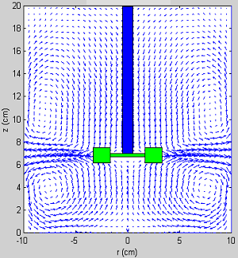
Jet in impeller plane
Eye of upper recirculating loop
Eye of lower recirculating loop

Figure 2-1. Classical Flow Structure in Stirred Tank Reactors

The difference in the performance characteristics of the measurement techniques used is one of the major reasons for the observed scatter in the reported data. A brief description of the different techniques along with the differences between them is briefly summarized in Table 2-1. Apart from the differences in the experimental techniques, the use of non-standard geometry of the experimental set-up is another contribution to the observed scatter. The hub dimensions, disc thickness and blade thickness are not yet standardized and yet all of them have a noticeable effect on the flow (refer to Figure 2-2).

H
T=200mm
H_{c}
D_{T}/10
φ= D_{T}/31.5
D
t_{b}
t_{D}
D/4
D/5
Disc
Blade

Figure 2-2. Details of the Stirred Tank Internals

Rutherford et al. (1996) examined the sensitivity of the measurements to some of these parameters. Their findings are summarized in Table 2-2(a) and in Figures 2-3 and 2-4. Figure 2-3 shows that a change in the blade thickness and disc thickness to impeller diameter ratio changes the mean radial velocity considerably. For a three fold increase in these ratios the mean radial velocities are reduced by almost 20%. However, it can also be seen that the maximum differences are only at the impeller tip and there are almost no differences away from the impeller. A similar effect on the radial rms velocities is reported in Figure 2-4, which shows that a three-fold increase in the thickness to diameter ratio reduces the radial rms by almost 25%. Table 2-2(b) summarizes the geometry of those studies reported in the literature, the results of which we intend on using here. This brief review summarized in Tables 2-1 and 2-2 and Figures 2-3 and 2-4 is intended to help us in identifying the reason for the differences in the quantitative comparisons reported later in this study.

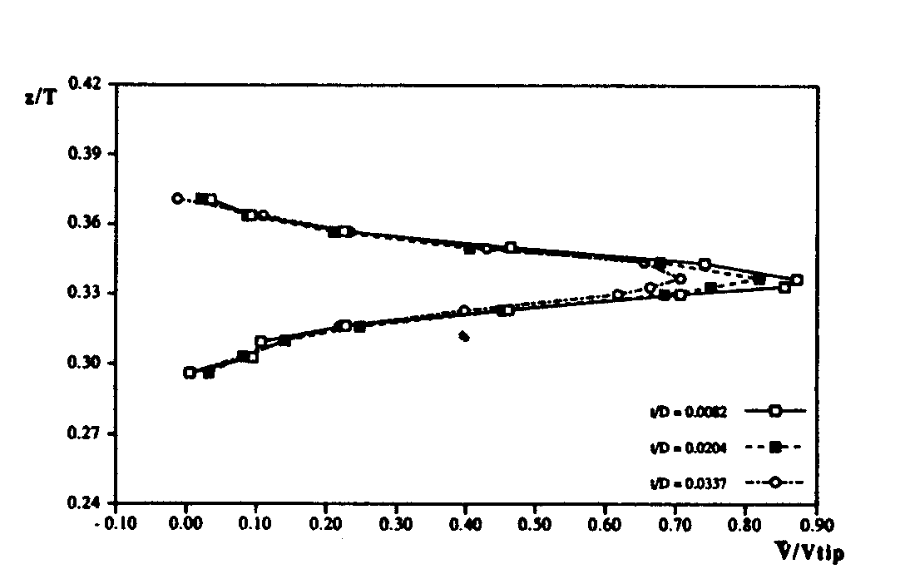

Figure 2-3. Effect of Blade and Disc Thickness Ratio on Mean Radial Velocity at r/T=0.17, Rutherford et al. (1996).
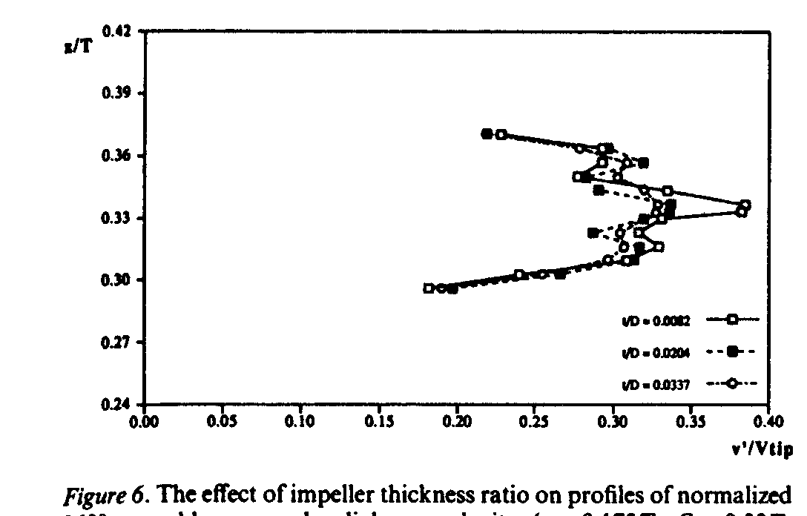

Figure 2-4. Effect of Blade and Disc Thickness Ratio on the Radial Root-Mean-Square Velocity at r/T=0.17, Rutherford et al. (1996).

As a first step in establishing the validity of their experimental data many researchers have reported mass balance verifications. The mass balance is usually verified in a control volume containing the impeller. These results have been summarized below in Table 2-2(c). Usually the mass balance is satisfied within 1-10% accuracy.

Table 2-2 (c). Verification of Mass Balance
Researcher | Technique Used | Region Considered | Accuracy
Gunkel and Weber (1975) | HFA | 0<z/D<.16, 0<r/D<1 | 4%
Yianneskis et al. (1987) | LDA | C.V. around impeller | 1%
Wu and Patterson (1989) | LDA | -.22<z/D<.22, 0<r/D<0.55 | 1%
Ranade and Joshi (1990) | LDA | C.V. around impeller | 5%
Yianneskis and Whitelaw (1993) | LDA | C.V. around impeller | 1%
Zhou and Kresta (1996) | LDA | -.15<z/D<.23, 0<r/D<.525 | 5-10%
This work | CARPT | C.V. around the impeller | 7%

As a next step, researchers have identified a number of reproducible physical phenomena that are qualitatively verified. One such phenomenon is the existence of the two ring like vortices one above and the other below the turbine impeller (refer to Figure 2-1). The radial location of the eye of the upper and the lower recirculation loops is reported to be 0.4r/T, while the axial location of the lower and upper recirculation loop eyes are around 0.2-0.25 z/T and 0.4-0.75 z/T, respectively. The differences in axial location are due to differences in the clearance of the impeller from the tank bottom. These results are summarized in Table 2-2(d). It must be emphasized that while the actual dimensions of the systems are different, a certain geometrical similarity exists between the systems. All the systems use the same type of impeller (Rushton turbine, with the same number of blades (6)), blade width to impeller diameter ratio of 1/5, blade length to impeller diameter ratio of 1/4, same impeller diameter to tank diameter ratio of 1/3 and same height of fluid to tank diameter ratio of one (1). This is summarized in Table 2-2(e). Although the actual dimensions of the different systems are different the dimensionless radial and axial locations of the eye of the loops are comparable. Radial and axial profiles of the dimensionless mean velocities and turbulent velocities (scaled with impeller tip speed) and the radial pumping number are also reported to be independent of the Reynolds numbers (for Re > 800) and of the actual dimensions of the system if the above mentioned geometric scaling is maintained. This enables the comparison reported by different researchers.

An overview of the literature suggests that many investigators place emphasis on the impeller discharge stream. Van’t Riet and Smith (1975) used stationary HFA and found that the rotation of the blade introduces a periodic flow around the impeller. Lee and Yianneskis (1994) used angle resolved measurements to quantify the extent of this periodicity. Stoots and Calabreese (1995) showed that the dimensionless extent of this region is independent of Reynolds number and scale of the system. These results have been summarized in Table 2-2(f) and provide the basis for the Multiple Reference Frame and Sliding Mesh simulations described later in this Chapter.

Many investigators report the presence of trailing vortices behind the impeller blades. Extensive descriptions of the vortex structures have been provided by Yianneskis et al. (1987). Some of their findings are summarized in Table 2-2(g). The flow in the impeller discharge stream is characterized by the existence of strong radial and tangential components of mean velocity and intense turbulence. This has been quantified by calculating the radial pumping number, the mean radial and tangential velocities, the rms velocities and the turbulent kinetic energy. These are summarized in Tables 2-2(h) and 2-2(i) respectively. The radial pumping numbers at the impeller tip are reported to be in the range of 0.64-0.83 with a mean of 0.75 +/- 0.15. The variation in this value is primarily due to the differences in the size of the control volume. Most of the investigators carry out the integration along the blade height, while some perform the integration up to the point where the radial velocity becomes zero. The latter case results in the higher pumping number (>0.8) while the lower values of 0.65 are due to the differences in the data acquisition technique used for LDA measurements. Conventionally LDA velocities are measured by focussing on a control volume, without accounting for the position of the impeller blade w.r.t. the control volume at the instant of the measurement. Such measurements are referred to as 360º ensemble averaged or time resolved data (refer to Figure 2-5(a)).
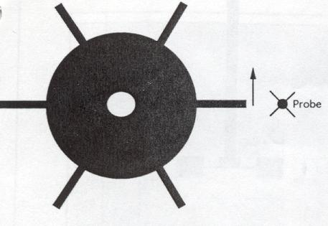
Stationary Probe

Figure 2-5(a). Schematic Depicting Ensemble Averaged Measurement in STR.

However, such measurements have an inherent data bias towards a higher mean velocity (Rutherford et al., 1996) since more than 50% of the sampled instantaneous velocities are within 1-20º behind the blade. Hence, Rutherford et al. (1996) suggested that a more accurate way of acquiring data would be to ensure that enough samples (500-750) are acquired in every 1º bin behind the impeller. Such data are collected over 60º and are then averaged to yield the “phase averaged” mean (refer to Figure 2-5(b)). The radial pumping number calculated using such measurements are
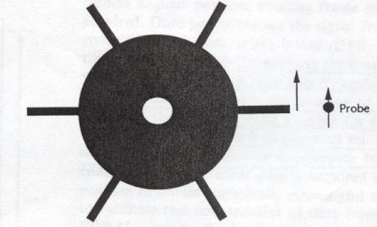
Probe rotates with impeller

Figure 2-5(b). Schematic Depicting Phase Averaged Measurement in STR.

reported to be 15% lower than the ensemble averaged radial pumping numbers (Stoots and Calabrese, 1995, and Rutherford et al., 1996). However, it is to be expected that even the ensemble averaged measurements should yield comparable values provided the data is sampled at a high enough sampling rate and for a long enough time. This is observed in the measurements of Kemoun (1991) who sampled data at 2048 Hz for 30s. The differences in sampling frequency and sampling time used by the different investigators are summarized in Table 2-2(j).

The observed differences in the reported mean velocities and turbulent kinetic energy are summarized in Table 2-2(i). Reported values of the maximum velocities V_{rmax}/V_{tip} vary from 0.58-0.88 and V_{θmax}/V_{tip} values range from 0.61-1.43. The reported rms values range from 0.20-0.41 for V_{r}`/V_{tip}, 0.2-0.454 for V_{θ}`/V_{tip} and 0.2 to

0.33 V_{z}`/V_{tip}. Reported turbulent kinetic energy K.E./V_{tip}² is in the range from 0.06 to 0.18. The “Phase averaged” mean velocities are reported to be 15% lower than the ensemble averaged mean velocities, while the phase averaged rms velocities are almost one fourth of the ensemble averaged velocities. Further, the differences in the blade thickness and disc thickness to tank diameter ratios affect the maximum mean velocities. Rutherford et al. (1996) have shown (Refer to Table 2-2(a) and Figures 2-1 & 2.2.) that a threefold increase in blade and disc thickness causes a 15% decrease in the maximum mean velocities and the rms velocities. However, this effect decreases as one moves away from the impeller. Recent DPIV measurements also report mean velocities and turbulent kinetic energies lower than LDA measurements. Fasano and Bakker (1993) reported the maximum axial velocity of 0.046V_{tip}, which is considerably lower than the LDA value of 0.15 V_{tip} (Ranade and Joshi, 1990). The radial velocities from DPIV are 40% lower than reported LDA values. Fasano and Bakker (1993) and Myers et al. (1997) attributed this discrepancy to high out of plane velocities near the impeller region and errors in cross correlation algorithm used (a detailed error analysis is reported by Westerweel in 1994). Deen and Hjertager (1999) reported the maximum radial velocity of 0.55V_{tip} which is lower than the LDA determined value of 0.7V_{tip}, (Wu and Patterson, 1989). The Root Mean Squared (rms) values in the radial direction and axial direction are within 10% of the LDA values. The turbulent kinetic energy values obtained by DPIV are within 15-20% of LDA values. Since this indicates that with the sampling frequency of 10-30 Hz DPIV can capture the turbulent kinetic energies well, then the frequencies below this range contain most of the energy containing eddies. Therefore, the higher frequencies probably contribute a smaller fraction of the total turbulent kinetic energy.

From the above literature review we have identified the different quantities that were measured by different experimental techniques. The range of variation of these parameters has been provided above and the possible reasons for the variations have also been discussed. Further, the literature search suggests that the dimensionless pumping number, mean and turbulent velocities from different studies are

comparable. In this work, we compare some of these quantities (mass balance, location of the circulation loops, radial pumping number, mean and turbulent velocities) computed from the CARPT measurements with similar measures obtained using the experimental techniques reviewed above.

2.2 Single Phase Flow Modeling

Detailed measurements of the flow in stirred tanks using LDA, DPIV etc. have contributed considerably to resolving large as well as small flow structures. Reliable models are needed to verify the information obtained and provide the means for prediction of flow patterns.

There are two basic modeling approaches, the phenomenological models and the numerical solution of the complete Navier Stokes equations. Ambegaonkar et al. (1977) and Fort et al. (1982) used approximate phenomenological models that yield analytical expressions for the mean velocity components in a stirred tank. These models however, tend to oversimplify the complexity of the flow and therefore, can at best represent only the mean velocity profiles. In order to capture the significant three-dimensional nature of the flow, rigorous numerical models are needed.

2.2.1 Numerical Solution of the Navier Stokes Equations

The stirred tank has internals of different shapes some of which (the rotating shaft and the impeller) are in motion. Until recently (Perng and Murthy, 1993) the impeller region was excluded from the solution domain and replaced by the boundary conditions on a control volume or by introducing source terms distributed throughout this volume. The boundary conditions or source terms were assigned using either experimental data or simplified models that ignore the overall geometry of the vessel. In most published papers (refer Table 2-4) the k- ε turbulence model has been used which requires boundary conditions for k and ε as well.

The applicability of the black box approach is limited by the availability of data. Moreover, this approach cannot be used to screen a large number of alternative mixer configurations. The extension to multiphase flows is not feasible because it is almost impossible to obtain accurate boundary conditions at the impeller. More importantly, this approach cannot capture the details of the flow between the impeller blades, which is

needed for realistic simulations of reactive mixing and multiphase flows in stirred reactors.

To eliminate some of these limitations five different models have since then been developed. Two of these are unsteady approaches: the moving mesh model and the sliding mesh model. Steady state models include the Multiple Reference Frame (MRF), Inner-Outer (IO) and the Snapshot Approach (SA). An introduction to these techniques along with a brief comparison of their predictive capabilities is discussed in Table 2-4. In this work, since both Computer Automated Radioactive Particle Tracking (CARPT) and Computed Tomography (CT) provide only time averaged values of the velocities and holdup it is sufficient at first to examine the steady state approaches of MRF and the SA. The value of the unsteady models lies in their ability to predict the dynamics of the flow particularly near the impeller region which is of interest if tracer run data or mixing time information is available for the system. Also the following considerations make unsteady approaches like the sliding mesh unattractive since at present:
- Computational requirements for the solution of full time varying flow in a stirred vessel are greater by an order of magnitude than those required by steady state simulations.
- Because of the excessive computational requirements, there are restrictions on the number of computational cells that can be used for these simulations. Such a limitation may make apriori predictions of the desired flow characteristics such as energy dissipation rates, shear rates etc. less accurate
- The results obtained using this approach are not yet sufficiently validated for the turbulent regime.
Hence, the two steady approaches alone are reviewed below.

Multiple Reference Frame (MRF) Model

Using sliding mesh simulations, Luo et al. (1994) showed that a cylindrical region enclosing the impeller exists, within which the flow is unsteady and outside which it is

steady. This allows us to assume the flow to consist of multiple “fluid” regions. The MRF method is a steady state model that simultaneously solves for the flow in a rotating fluid region enclosing the impeller and a stationary fluid region containing the walls, the baffles and the bulk of the tank. The solution from both the reference frames is matched at the interface between the rotating and the stationary fluid region. The effect of rotation is accounted for by the inclusion of the Coriolis acceleration term and the centrifugal force term. Luo et al.’s (1994) comparisons between the predicted axial, radial velocities and LDA data of Yianneskis et al. (1987) were good. There were slight differences between measured and predicted tangential velocities.

Snapshot Approach (SA)

The interaction between the rotating blades and the stationary baffles generates an inherently unsteady flow. Once the flow has developed, the flow pattern becomes cyclic. A snapshot of the flow can therefore describe the flow between the impeller blades at that particular instant. Ranade and Van den Akker (1994) developed this snapshot approach. The flow generated by an impeller is governed mainly by the pressure and centrifugal forces generated by the impeller rotation. The pressure forces cause the suction of the fluid behind the blade and an equivalent ejection in front of the blade. In the SA this suction and ejection is modeled by specifying mass sources on the front side of the blade and sinks on the back side of the blades. The mass source term is the same as the mass sink with an opposite sign. Inward movement does not add any corresponding source to the other variables. The comparisons of computed results using the snapshot approach and data (Ranade and Joshi, 1990) for single phase flow are good qualitatively and quantitatively. The equations used in the MRF and the snapshot approach are summarized below.

The transport equation for a general variable, φ, can be written for an incompressible steady flow as:
$\begin{aligned}\frac{1}{r}\frac{∂}{∂r}\left(ρ{\text{rV}}_{r}φ\right) + \frac{1}{r}\frac{∂}{∂θ}\left({ρV}_{θ}φ\right) + \frac{∂}{∂z}\left({ρV}_{z}φ\right) \\ =\frac{1}{r}\frac{∂}{∂r}\left({Γφ}_{\text{eff}}r\frac{∂φ}{∂r}\right) + \frac{1}{r}\frac{∂}{∂θ}\left(\frac{{Γφ}_{\text{eff}}}{r}\frac{∂φ}{∂θ}\right) + \frac{∂}{∂z}\left({Γφ}_{\text{eff}}\frac{∂φ}{∂z}\right)+S_{φ} (2\text{.}1)\end{aligned}$

Γ_{φeff} denotes an effective turbulent exchange coefficient including the molecular contribution and S_{φ} denotes the volumetric rate of growth or decay in φ because of the internal and external sources. The details of the source terms for various φ are given below.

Table 2-3. Summary of Equations Used for the MRF and SA models
φ | Γ_{φ} | S _{φ}
1 | 0 | 0
V_{r} | μ_{eff} | $$\frac{1}{r}\frac{∂}{∂r}\left(μr\frac{∂V_{r}}{∂r}\right)+\frac{1}{r}\frac{∂}{∂θ}\left(μr\frac{∂}{∂r}\left(V_{θ}r\right)\right)−\frac{2μ}{r^{2}}\frac{∂V_{θ}}{∂θ}+\frac{{ρV}_{θ}^{2}}{r}+\frac{∂}{∂z}\left(μ\frac{∂V_{z}}{∂r}\right)−\frac{∂p}{∂r} (2\text{.}2)$$
V_{z} | μ_{eff} | $$\frac{1}{r}\frac{∂}{∂r}\left(μr\frac{∂V_{r}}{∂z}\right)+\frac{1}{r}\frac{∂}{∂θ}\left(μ\frac{∂}{∂z}\left(V_{θ}\right)\right)+\frac{∂}{∂z}\left(μ\frac{∂V_{z}}{∂z}\right)−\frac{∂p}{∂z} \left(2\text{.}3\right)$$
V_{θ} | μ_{eff} | $$\begin{aligned}μ\frac{∂}{∂r}\left(\frac{V_{θ}}{r}\right)−\frac{1}{r}\frac{∂}{∂r}\left({μV}_{θ}\right)−\frac{{ρV}_{r}V_{θ}}{r}+\frac{μ}{r^{2}}\frac{∂V_{θ}}{∂θ}+\frac{1}{r}\frac{∂}{∂r}\left(\frac{μ}{r}\frac{∂V_{θ}}{∂θ}\right) \\ +\frac{1}{r}\frac{∂}{∂θ}\left(\frac{2{μV}_{r}}{r}\right)\frac{{ρV}_{θ}^{2}}{r}+\frac{∂}{∂z}\left(\frac{μ}{r}\frac{∂V_{z}}{∂θ}\right)−\frac{1}{r}\frac{∂p}{∂θ} (2\text{.}4)\end{aligned}$$
k | μ_{eff}/σ_{k} | $$G−\text{ρε} \left(2\text{.}5\right)$$
ε | μ_{eff}/σ_{ε} | $$\frac{ε}{k}\left(C_{1}G−C_{2}\text{ρε}\right) \left(2\text{.}6\right)$$

And
$$\begin{aligned}G=μ_{t}\left(2 \left[{\left(\frac{∂V_{r}}{∂r}\right)}^{2}+ {\left(\frac{1}{r}\frac{∂V_{θ}}{∂θ}+\frac{V_{r}}{r}\right)}^{2}+ {\left(\frac{∂V_{z}}{∂z}\right)}^{2}\right] + {\left[r\frac{∂}{∂r}\left(\frac{V_{θ}}{r}\right)+\frac{1}{r}\frac{∂V_{r}}{∂θ}\right]}^{2}\right) \\ +μ_{t}\left({\left[\frac{1}{r}\frac{∂V_{z}}{∂θ}+\frac{∂V_{θ}}{∂z}\right]}^{2} + {\left[\frac{∂V_{r}}{∂z}+\frac{∂V_{z}}{∂r}\right]}^{2}\right) (2\text{.}7)\end{aligned}$$

Where
$$μ_{\text{eff}}=\frac{C_{D}k^{2}}{ε}+μ \left(2\text{.}8\right)$$

In the Snapshot approach the source terms $φ$ have an additional contribution to account for the impeller rotation. These are given by
$$S=−{ρA}_{\text{bc}}W \left(2\text{.}9\right)$$
and the Sink terms for other variables are obtained from
$$S_{φs}=Sφ \left(2\text{.}\text{10}\right)$$

Similarly, for the cells in front of the blade a mass source similar to (2.9) but with an opposite sign is specified. The inward motion of the blade does not result in transport of other quantities (like momentum and turbulent kinetic energy). In the MRF model the source terms for momentum contain two additional terms to account for the Coriolis acceleration and the Centrifugal force. These are given below:
$$F_{r}=ρ\left(ω^{2}r+2{ωV}_{θ}\right) \left(2\text{.}\text{11}\right)$$
$$F_{θ}=ρ\left(−2{ωV}_{r}\right) \left(2\text{.}\text{12}\right)$$

It must be mentioned that both the MRF and the computational snapshot approach look promising as design tools since these can be easily extended to any number of impellers and to multiphase flows, without excessive demands on computational resources.

Approximations employed with both MRF and snapshot methods are of the same level and therefore lead to almost the same results
The boundary conditions for both approaches require no empirical inputs unlike the black box approach. For the MRF model the rotating frame is defined to rotate as a solid body with the angular speed of interest. In both Snapshot and MRF approach the impeller disc, the shaft and the blades are all explicitly defined as rotating solid walls. The vessel walls and baffles are defined as impermeable walls with friction. The boundary conditions for velocities at the walls and baffles are set to zero, and the boundary conditions for turbulence are defined using the standard wall function option provided by FLUENT. The top of the liquid is defined as a free surface. The vertical center-line is defined to be the axis of rotation. The angular planes corresponding to the start of the domain and end of the domain are rotationally symmetric.

A summary of the different modeling approaches is provided below in Table 2-4.

2.2.2 Models for Turbulence

In the stirred tank literature the most commonly used model for turbulence is the standard k-ε model. This model has been reviewed extensively (Ranade and Joshi, 1990). Hence, in this section we summarize the use of other turbulence models. Placek et al. (1986) used a modified k-ε model. They introduced an alternate balance equation for the turbulent kinetic energy of large-scale vortices. They solved the transport equations for the turbulent kinetic energy of production scale vortices (k_{T}) and the inertial range vortices (k_{P}) along with the rate of dissipation (ε) and the momentum equations. The agreement between predicted and measured mean velocities was not satisfactory. They have not reported quantitative comparisons of the turbulent kinetic energy.

Jenne and Reuss (1999) selected two modified versions of the k-ε model which account for the non-equilibrium process, one was Chen and Kim’s model (CK, 1987) and the other the renormalization group theory (RNG) proposed by Yakhot and Orszag (1986). Their results suggest that the standard k-ε model predicted the mean velocities within 10% of experimental data and the turbulent kinetic energies within 24%. This was in better agreement than achieved by the other two models for which the mean velocity deviations were about 25% for CK and 40% for RNG model, while the deviations in the kinetic energy were 30%(CK) and 50%(RNG). Jenne and Reuss (1999) do not attempt to explain this discrepancy. Moreover, they used the black box approach to model the impeller region. Therefore, it is unclear whether the deviations are entirely due to the different turbulence models or if they are somewhat caused by the black box method. Oshinowo and Marshall (1999) compared the effects of using different turbulence models in the MRF approach, and concluded that not much difference could be seen in the mean velocity and turbulence predictions. Ng et al (1998), who reported sliding mesh simulations with the standard k-ε model, suggested that a different turbulence model like the Reynolds Stress Model (RSM) might do a better job. On the contrary, Revstedt et al. (1998) reported that the RSM model parameters are not universal, cannot handle fully

developed turbulence nor mixed laminar/turbulent flows and that moreover RSM, which requires solving an enlarged system of seven additional PDE’s, has difficulty in convergence.

Large Eddy simulations in stirred tanks have been reported by Revstedt et al. (1998), Derksen et al.(1998) and Derksen and Van den Akker, (1999). Revstedt et al. (1998) overpredict the azimuthal and radial velocities, pumping numbers and the rms values when compared with experimental data of Wu and Patterson, (1989). Derksen and Van den Akker’s (1999) comparisons of the radial velocities with Wu and Patterson, (1989) and Derksen et al’s (1998) LDA data are good. The tangential velocities are overestimated with maximum deviations of 15%. The computed turbulent kinetic energy shows broader peaks and larger magnitude near impeller than the data. The deviations from data are attributed to the lack of adequate spatial resolution (currently they use six million nodes) and not accounting for the solid wall in the sub grid scale model. While the LES models resolve more scales of turbulence than the standard turbulence models, both LES simulations discussed above overestimate the experimental values. The price at which this extra information is obtained i.e. long integration times, huge grids, higher order discretization schemes etc. currently does not justify the use of this scheme.

2.3 Multiphase Flows – Experimental Characterization

Unlike the extensive characterization of single phase flows in stirred tanks, the study of multiphase flows has been restricted to determination of global parameters like power consumption, relative power demand, overall holdup measurements, mixing time measurements and critical impeller speed required for complete homogenization or suspension. Only a few studies such as those of Lu and Ju (1987), Morud and Hjertager (1996), and Deen and Hjertager (1999), report the local quantities. We review each of these studies below.

Lu and Ju (1987) used HWA to simultaneously measure the local gas (air) holdup (accuracy is within 20%), the resultant mean liquid velocity (within 5% accuracy) and the root mean square (rms) fluctuating velocity of the liquid which was filtered tap water. They used a standard tank (28.8 cm diameter) with a disc turbine and a perforated ring sparger of 8 cm diameter. Measurements were made in the impeller discharge stream, confined to a vertical plane midway between the two baffles. The holdup, mean liquid velocity and turbulent intensities’ variations with impeller speed and gas sparging rate at different radial and axial locations are reported. They report holdups in the range of 5-25 %T. They have performed experiments from 400 to 720 rpm. These quantities can also be obtained using CT and CARPT as discussed later on in this work (Chapter 7).

Morud and Hjertager (1996) measured the mean and turbulent gas velocities using LDA. They used a tank of standard dimensions (0.222m in diameter), with a dished bottom, a Rushton turbine, with length of blade = width of blade =1/4 impeller diameter, and with a clearance from the bottom of the tank of 0.47T. Gas (air) was introduced through an inlet pipe and entered through a porous sparger below the impeller. The vessel was operated at 360, 400, 560 and 720 RPM and gas flow rates Q= 0.49, 0.75, 1 and 1.33 volumes of gas per volume of liquid per minute (vvm). Their overall gas holdup varied from 1-8 %. They reported the gas phase radial velocity variations with RPM and the gas velocities at three different heights (h= 0.23D, 0.47D and 0.72D) using Phase Doppler anemometry. Gas phase turbulence seems to be isotropic. The radial velocities were measured every 5 mm in the radial direction and at an angle of 5 degrees relative to the baffles. Overall gas holdup variation with impeller rotation speed was reported. This work is very systematic and provides information that can be compared to data to be obtained from CT studies. Deen and Hjertager (1999) used DPIV to study the liquid phase properties for the same system as used by Morud and Hjertager (1996). Together they provide a relatively complete characterization of the gas-.liquid system in the stirred tank at low to modest gas holdups (1-7%). Deen and Hjertager (1999) performed measurements at impeller speed of 360 rpm and gas flow rate of 0.5 vvm. They compared the axial profiles of their radial and axial velocity, both with and without gas, with LDA data of Wu and Patterson

(1989) obtained without gas. The maximum radial velocity without gas was 23% lower and with gas was 80% lower than indicated by Wu and Patterson’s (1989) liquid phase data. They did not measure the tangential velocities.

In summary, while Morud and Hjertager (1996) and Deen and Hjertager (1999) reported detailed measurements of gas phase and liquid phase velocities, both studies are restricted to low gas holdup fractions in the range of 0.01-0.07. Only Lu and Ju (1987) measured simultaneously liquid phase velocity, turbulence parameters and gas holdup fractions. Unfortunately, Lu and Ju (1987) reported only the resultant liquid velocities (not individual components) and their gas holdup measurements are not accurate, with errors as high as 20%. Hence, for gas-liquid systems there is a clear need for accurate and reliable information on the fluid dynamics of the liquid and gas phase, especially at higher gas holdup fractions. Given this, we would like to initiate the creation of a reliable database for the estimation of important fluid dynamic parameters for gas-liquid flows in stirred tanks using CARPT and CT.

2.4 Multiphase Flows – Numerical Simulations
Pericleous and Patel (1987) modeled gas-liquid flows in stirred vessels using an algebraic slip model. Momentum equations were solved using mixture properties. The presence of bubbles was accounted for by solving a convection diffusion equation with a constant slip velocity. The bubble concentrations were used to update the mixture density. Gosman et al. (1992) reported 3-D simulations of gas–liquid and liquid-solid flow in a stirred vessel using the black box approach. They used a two-fluid model with a k-ε turbulence model extended for two-phase flow (with consistent definitions for k and ε in the Favre averaged sense). Their gas-liquid simulations underestimated the measured gas holdup by 10-50 % according to the data of Revill and Irvine (1987), and the slip velocities predicted by their liquid-solid simulations are around 0.04m/s which is of the order of their particle settling velocities. The gas holdup underestimation is attributed to not modeling the coalescence and redispersion phenomena. Daskopoulos and Harris (1996)

suggested that Gosman et al.’s (1992) solid concentrations may be too dilute to draw any meaningful conclusion from their work.

Ranade and Van den Akker (1994) extended the snapshot approach (SA) to three dimensional multiphase simulations. They used a two-fluid model like Gosman et al. (1992) but employed a Reynolds averaging approach unlike Gosman et al. (1992) who used the Favre averaging. Although Favre averaging leads to fewer terms requiring closure, the experimental techniques, provide us with Reynolds averaged information. The SA model, unlike Gosman’s, requires no experimental input for the impeller region. Ranade and Van den Akker (1994) compared their results with the experimental data of Rousar and Van den Akker (1994). The comparison between the predicted and experimental axial velocities is shown below in Figure 2-6. The axial velocity is over estimated near the impeller (maximum deviation within 35-40%) and underestimated near the wall.
CFD
Data

Figure 2-6. Comparison of Predicted Radial Profiles of Axial Mean Velocity (Liquid) with Experimental Data at z/R=0.33 and Q_{g}= 8 l/min

The comparison between the experimental and the predicted tangential velocities is shown in Figure 2-7. The tangential velocities are underestimated near the impeller region (maxium deviation within 21%) while the velocities are considerably overestimated near the wall (around 40% deviation from the data). Lack of adequate spatial resolution is cited as a reason for this difference.

CFD
Data

Figure 2-7. Comparison of Predicted Radial Profiles of Tangential Mean Velocity (Liquid) with Experimental Data at z/R=0.33 and Q_{g}=8 l/min

The comparison between the experimental and predicted turbulent kinetic energy is shown below in Figure 2-8. Rousar and Van den Akker (1994) have reported only the axial and tangential fluctuating velocities. Hence the kinetic energy is calculated assuming isotropy. The kinetic energy is underestimated by almost 90% near the impeller tip while it is overestimated by 53% near the wall.

The predicted and experimental relative power demand is compared below in Figure 2-9. The predictions underestimate the reduction in power demand (maximum deviation is 67%). Inadequate grid resolution is cited as the reason for the quantitative differences. However, the model is seen to predict the right qualitative trend.
CFD
Data

Figure 2-8. Comparison of Predicted Radial Profiles of Turbulent Kinetic Energy with Experimental Data at z/R=0.33 and Q_{g}= 8 l/min
CFD
Data

Figure 2-9. Comparison of Predicted Drop in Power Consumption at Different Gas Flow Rates

The comparison between predicted and measured overall gas holdup is shown below in Figure 2-10. The predicted gas holdup profiles compare very well with the measured holdup values (maximum deviation is around 5%). However, the maximum holdup studied was 5%.
CFD
Data

Figure 2-10. Comparison of Predicted Overall Gas Holdup with Experimental Data.

Thus, the Snapshot approach is seen to predict the qualitative trends well and the quantitative agreement is reasonable given that the model requires no experimental input (other than the bubble diameter for the two fluid model). The model is also reported to capture the right trend for other phenomena like accumulation of gas behind the impeller, pressure distributions in the impeller region, angular variations of gas and liquid velocity around the impeller tip, etc. Clearly with additional improvement (like adequate spatial resolution, customized drag formulations etc.) the model has potential to be validated with two phase data.

Morud and Hjertager (1996) reported a two-dimensional, two-fluid simulation with the standard k- ε model. They modeled the impellers and baffles with source and sink terms (like Pericleous and Patel, (1987)). Comparisons between the measured and the simulated overall gas holdup and of the relative power demand variation with gas flow rate are

reasonable (predictions within 20-40% of data). The mean velocity predictions of the gas phase near the impeller compare well with the data but the velocities are overestimated in the bulk. Qualitative profiles of the tangential velocities compare well with measured data. The conditions used by Morud and Hjertager (1996) are different and one reports liquid phase velocities while the other reports gas phase velocities. Hence there is little scope for comparing the two studies.

The above review suggests that multiphase flow modeling in stirred tanks is still in a nascent stage. Given the unavailability of a detailed experimental database for multiphase flows in stirred tanks, methods like the Snapshot approach, MRF and sliding mesh approach which require no experimental inputs are preferred over the black box approaches. Out of the above three methods we propose to examine the predictive capabilities of the SA to simulate gas–liquid flows in stirred tanks.

