Chapter 3

A Lagrangian Description of Flows in Stirred Tanks Via Computer Automated Radioactive Particle Tracking (CARPT)

3.1 Introduction
In this chapter Computer Automated Radioactive Particle Tracking (CARPT) is implemented for the first time in characterization of flows in stirred tanks. Both the experimental technique and the experimental set up are discussed. A qualitative assessment of the CARPT results obtained in a STR using water as the fluid is provided. The objective of this study is to establish the type of information that CARPT can provide in single phase flows in stirred tanks. This is followed by quantitative comparison with data obtained by established techniques like LDA and DPIV (Chapter 4). The ultimate objective is to use CARPT in opaque multiphase flows in stirred tanks at conditions inaccessible to other measurement techniques.

3.2 Experimental Setup

3.2.1 The Stirred Vessel

The stirred vessel used is of the standard Holland and Chapman type (1966) consisting of a cylindrical tank with four baffles and a stirrer (Figure 3-1). All the parts are made of a transparent material (clear plexi glass). The diameter of the vessel is D=0.2m. The baffles are D/10 in width and D/125 in thickness, vertical and flush with the wall. The agitator is a Rushton turbine composed of a disc of D_{I}= D/3 overall diameter with six rectangular

radial blades of w=D/15 height and thickness D/125. The turbine is located at a distance D_{I} from the bottom of the tank which is filled with water to a height equal to the tank diameter. The shaft diameter is D/31.5 and the disc thickness is D/67.
H
T
=D
T
T= D
T
=200mm
D
T
/
3
D
T
/10
D_{I}=D
T
/3
3D_{I}/4
D_{I}/4
D_{I}/5

Figure 3-1. Stirred Tank of the Holland–Chapman type Used for the CARPT Experimental Study

3.2.2 The CARPT Setup

The CARPT set up consists of 16 scintillation detectors (Figure 3-2) mounted on aluminum supports, which are arranged on an octagonal base. There are eight aluminum supports placed around the tank at 45 degrees to each other. Each support has two holes of diameter 2.2’’ (5.6 cms). The axial location of the center of the holes from the octagonal base plate is as follows: The lowest hole is at a distance of Z₁=2.86 cms, then Z₂=7.72 cms, Z₃=12.59 cms and Z₄=17.45 cms. Every aluminum support has the holes placed, either at Z₁ and Z₄ or at Z₂ and Z₃. Every consecutive support has alternate locations of the holes. This configuration optimizes the extent to which the particle can be seen by each detector in the tank (Degaleesan, 1997). Each detector unit is a cylinder

2.125’’(5.4 cms) in diameter and 10.25’’ (26.0 cms) long, and contains an active cylindrical Sodium Iodide crystal (2’’ X 2’’ i.e. 5.08 cms X 5.08 cms). Every axial level has four detectors each at right angles with the others. These detectors are placed at the above mentioned four different axial levels. The detectors at each axial level are staggered by 45 degrees with respect to the previous level.
16 Detectors
Octagonal base

Figure 3-2(a). Top View of CARPT Setup for the Stirred Tank

The radioactive particle (Figure 3-3), the position of which is tracked, is about 2.3 mm in diameter, made of polypropylene with radioactive Scandium embedded in it (Sc-46, 80 μCi) and with an air pocket so that the effective density of the particle is equal to that of water (or the fluid tracked). In spite of the fact that the tracer particle is neutrally buoyant, its size is too large to enable it to follow all the energy containing eddies in the flow. This particle was chosen because it was readily available to test the CARPT technique in stirred tanks. Once feasibility is established one can search for a more suitable tracer size

to reach a compromise between size and density mismatch. We discuss the limitations of the current tracer particle in the subsequent section.
Sc-46, 2.36 mm
16
Na I
detectors
Al Supports
Z₄ = 17.45 cms
Z₃ = 12.59 cms
Z₂ = 7.72 cms
Z₁ = 2.86 cms

Figure 3-2(b). Front View of CARPT Setup for the Stirred Tank

Figure 3-3. Details of the CARPT Tracer Particle

3.2.3 The CARPT Technique

Devanathan (1991) adapted the Computer Automated Radioactive Particle Tracking (CARPT) technique to study the motion of the liquid phase in bubble columns. A single radioactive particle, that is neutrally buoyant with respect to the liquid being tracked, was used with radioactive Scandium, Sc-46, emitting γ radiation employed as the isotope. During an experiment, as the particle moves about in the vessel tracking the liquid phase, the position of the particle is determined by an array of scintillation detectors that monitor the γ radiation emitted by the particle. The radiation intensity recorded at each detector decreases exponentially with increasing distance between the particle and the detector. In order to estimate the position of the particle from the radiation intensities, calibration is performed prior to a CARPT experiment by placing the particle at various known locations and monitoring the radiation recorded by each detector (Figure 3-4). Using the information acquired, calibration curves are established that relate the intensity received at a detector to the distance between the particle and the detector (Figure 3-5). Once the distance of the particle from the set of detectors is evaluated, a weighted regression scheme is used to estimate the position of the particle at a given sampling instant in time. Thereby a sequence of instantaneous position data is obtained that yields the position of the particle at successive sampling instants (Figure 3-6). In our experiments the sampling frequency was 50 Hz, i.e. particle position is identified at 0.02 seconds intervals. Time differentiation of the successive particle positions yields the instantaneous Lagrangian velocities of the particle, i.e., velocities as a function of time and position of the particle. Ensemble averaging of the Lagrangian particle velocities, detected in each of the compartments into which the tank has been subdivided to, is performed to calculate the average velocities and the various “turbulence” parameters of the liquid. Clearly, due to finite size of the particle, we are not capturing the true and fine scale liquid turbulence but rather various cross correlations of particle velocity fluctuations around the mean.

radioactive
particle
Al rod for changing
z location
Slots to calibrate at
different radial locations
Theta
graduations to
calibrate at
different
angles

Figure 3-4. Details of the CARPT Calibration Procedure.

3.3 Measurement Errors

A preliminary identification of the different sources of errors in CARPT measurements is discussed here. A more detailed quantitative analysis of the various errors is discussed in Chapter 5.

3.3.1 Tracer Ability to Follow the Liquid

The accuracy of determining the liquid velocity using the particle tracking technique depends in part on the ability of the tracer particle to follow the liquid. Close matching of the density of the particle with that of the liquid ensures that the particle is neutrally buoyant. However, the finite size of the particle makes it differ from a liquid element, unable to sample the small scale eddies. Devanathan (1991) showed that for a particle of size 2.36 mm, and a difference of 0.01 gm/cm³ in density between the particle and the liquid, the maximum difference in the velocities (between particle and liquid) is 1cm/s.

Degaleesan (1997) estimated that the maximum frequency at which the 2.36 mm particle can be taken to follow up to 99.0% of the liquid velocity is 30Hz. She also showed that for frequencies smaller than 30 Hz, which represent the large scale eddies, the particle is able to closely follow the liquid phase, and the measured particle fluctuating velocities can be considered to be those of the liquid phase. Higher frequency eddies cannot be followed by the current particle (for further analysis refer to Chapter 5, section 5.3.4.4).

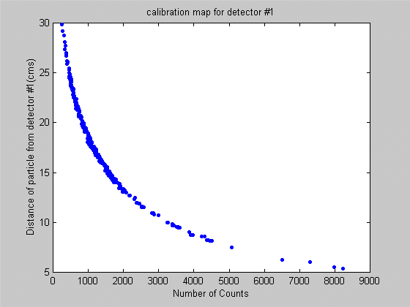

Figure 3-5. Calibration Map for Detector #1

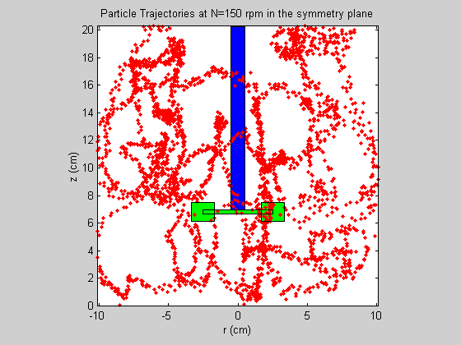

Figure 3-6. Projection of the Particle Trajectory in a Vertical Plane at N = 150 rpm for

30 s

3.3.2 Statistical Nature of Gamma Photons
The emission of gamma photons from a radioactive source follows a Poisson distribution (Tsoulfanidis, 1983). Therefore every mean count reported in the calibration curve is associated with a distribution of counts. When reconstructing the particle position from the instantaneous counts registered by each detector only the mean values are used, while in reality the counts measured will be but one value from the distribution seen around the mean. Hence, the reconstructed particle position will not be the exact instantaneous position. The error in reconstructing the particle position along a known trajectory (a

circular one when particle is placed in the impeller disc at r=6.0 cms, Z=6.67 cms) is found to be less than 3mm (for more details refer to Chapter 5 section 5.2).

3.3.3 Solid Angle Effect

Devanathan (1991) showed that the solid angle has a significant effect on the detected radiation intensity and that the side face of the detector composed of Sodium Iodide (NaI) cylindrical crystal is more effective than the front face from the standpoint of detection. If many detectors see the particle, each with a different solid angle, then the errors introduced by some detectors are partially compensated for by the other detectors resulting in better accuracy. To obtain higher accuracy in tracer location, solid angle effects have to be considered in the calibration. To some extent this has been implemented by Degaleesan (1997), by using a two step method in reconstructing the particle position. In the second step solid angle effects are taken into account. Further improvements can be accomplished by modeling the various interactions of the radiation with the medium and the detector crystal. Modeling of the gamma ray interactions using Monte Carlo simulations has been successfully performed by Larachi et al. (1994) who has used radioactive particle tracking to study the behavior of solids in ebullated beds.

Given the above possible sources of errors in reconstructing the particle position in a stirred tank, and considering the estimates of their maximum magnitudes, we find the accuracy in reconstructing particle position to be reasonably good. This can be seen from the fact that the reconstructed particle positions are hardly ever located in the region of the baffles which are about 1.5 mm thick (Figure 3-7).

3.4 Experimental Conditions

Water is used as the fluid whose motion is tracked by the radioactive particle. Experiments were conducted at 150 rpm (Re_{imp} =12,345) at room temperature. The height of the liquid in the tank was 20.0 cm (equal to tank diameter).
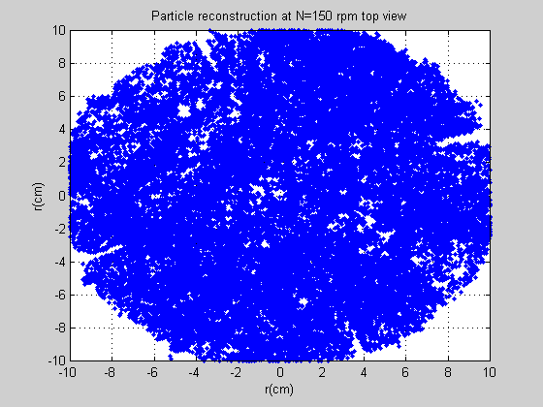
Baffles

Figure 3-7. Projection of the Reconstructed Particle Position at N = 150 rpm (Top View for 1 hr of the 16 hr Run)

3.5 Results and Discussion

3.5.1 Validity of Experimental Data
As a first step in establishing the validity of their experimental data, different researchers have reported mass balance verifications. The balance is usually verified in a control

volume containing the impeller. These results have already been summarized in Table 2-2(c) which shows that the mass balance is usually satisfied within 1-10% accuracy. Table

2-2(c) suggests that CARPT’s accuracy in closing the mass balance within 7% is comparable to other techniques.

3.5.2 Location of the Eye of the Recirculating Loops
The azimuthally averaged velocity in the r-z plane is displayed in Figure 3-8. The velocity vector plot captures the key qualitative features expected in this stirred tank configuration (Van Molen and Van Maanen, 1978; Yianneskis et. al., 1987; Costes and Couderc, 1988; Wu and Patterson, 1989; and Ranade and Joshi, 1990). There is a radial jet in the plane of the impeller, which goes right to the walls. This high-speed radial jet entrains the surrounding fluid and slows down as it approaches the tank wall. Near the tank wall, the jet stream splits into two portions, one of which then circulates through the upper and the other through the lower portion of the tank and both are finally drawn back into the impeller region. These two streams result in the two recirculation loops seen in Figure 3-8. One loop is above the impeller and the other below the impeller. Both circulation loops exhibit what is conventionally called the eye of the loop. The vertical position of the eye of the upper loop is found to be around D/2 and the eye of the bottom loop is at an elevation around D/5 (where D is tank diameter) with the radial location of both loops at 2D/5. This compares well with the dimensionless locations reported by other researchers as evident from Table 3-1.

3.5.3 Mapping the Dead Zones in the Stirred Tank

At the bottom of the stirred tank the influence of the impeller is not as pronounced as in the rest of the tank. This results in regions of very low velocities at the bottom of the tank where fluid elements (or dispersed phase like solid particles) tend to spend much longer time than in other portions of the tank. The presence of such regions can lower the mixing

efficiency. The existence of such zones has been identified by flow visualization studies (Kemoun, 1995). Kemoun introduced a number of polypropylene beads (of d_{P}=0.3 mm
and ρ_{P} = 0.8 gm/cc.) into the water flow in the same tank configuration as used in this work and illuminated the bottom of the tank with a laser sheet.
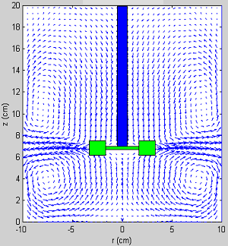

Figure 3-8. Azimuthally Averaged Velocity Vector plot at N = 150 rpm

Table 3-1. Location of the Eye of Circulation Loops (T = D = tank diameter)
Researcher | Lower r/T | Lower z/T | Upper r/T | Upper z/T | Clearance Hc/T
Yianneskis et. al. (1987) | 0.3 | 0.20 | 0.30 | 0.48 | 0.33
Costes and Couderc (1988) | 0.4 | 0.25 | 0.4 | 0.75 | 0.50
Schaefer et. al. (1997) | 0.4 | 0.20 | 0.4 | 0.5 | 0.33
Kemoun, et. al. (1998) | 0.4 | 0.20 | 0.4 | 0.5 | 0.33
Current work | 0.4 | 0.20 | 0.4 | 0.5 | 0.33

The regions with higher number of particles reflect more light and appear as the bright regions in the photograph. We reproduce here one such snapshot taken by Kemoun (1995) in Figure 3-9a where the bright spots can be seen to be in the form of a starfish like pattern. These bright regions correspond to the dead zones where particle velocities are low causing more particles to accumulate and settle. A similar plot has been generated from the CARPT data where the vector plot of the resultant of the radial and the tangential velocity at the bottom of the tank is shown in Figure 3-9b. The plot is colored with the contours of the total velocity vector in this plane. The blue regions show the regions of very low velocity. The yellow regions show the regions of high velocity. At the bottom the dead zone can be seen clearly and it seems to resemble a starfish. The interesting thing is that these dead zones seem to be due to a swirling tornado like structure, which starts just below the impeller plane and is entirely three dimensional in nature. The instability seems to begin at the baffles and slowly propagates downward until the starfish like pattern is observed at the bottom. This comparison of CARPT obtained results with direct flow visualisation illustrates CARPT’s potential for capturing important flow phenomena.

Figure 3-9a. Dead Zones from Flow Visualization Studies (Kemoun, 1995)

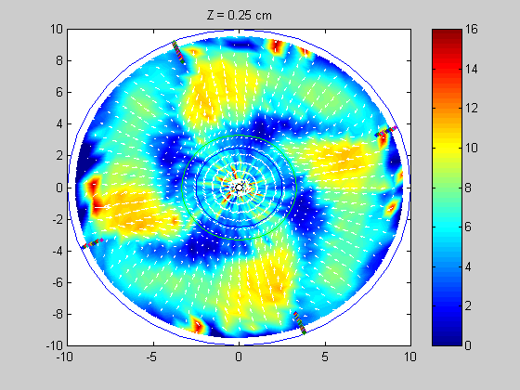
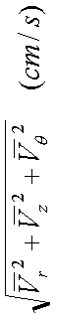
Dead zones
Star Fish Pattern
R cm
R cm
θ
V
V
r
.
Disc
Blades
Baffles
Plane at the bottom of the tank

Figure 3-9b. Map of Dead Zones from CARPT

3.5.4 Partial Quantification of Dead Zones Using Sojourn Time Distributions (STDs)

In this study we extract the Sojourn Time Distribution (STD), i.e. strictly speaking the probability density function of Sojourn times for different regions in the tank, from the CARPT experiment. For illustrative purposes we have divided the tank only in the axial (vertical) direction into ten regions, each 2cms in height as shown in Figure 3-10. For each of these zones we compute the STD, as illustrated below, and we display the STDs in Figure 3-11. It is important to note that any desired additional compartmentalization in the angular (θ) and radial (r ) direction is possible. Thus, STDs can be calculated from the experimental CARPT data for any region of interest in the stirred tank.

Neutrally Buoyant tracer
Zone 4
Zone 2
Zone 6
Zone 8
Zone 10
H
T
=D
T
D
T
=200mm
D
T
/3
D
T
/10
Zone 1
Zone 3
Zone 1
Zone 5
Zone 7
Zone 9

Figure 3-10. Compartmentalization of the Stirred Tank into Axial Zones

$t_{\text{res}1}=N⋅Δt \left(3−1\right)$We obtain the STD for an axial slice of the tank, defined above in Figure 3-10, as follows. From the CARPT experiment the record of the particle trajectory as a function of time is available with the time starting at zero and with every subsequent particle location recorded at intervals of Δt= 0.02 seconds (corresponding to f_{sample}= 50Hz). Hence, the N^{th} particle position corresponds to the time of NΔt seconds since the start of the experiment. To generate the STD curve for each zone, the records of the particle positions are scanned until the particle is found in the zone of interest (i.e. the axial co-ordinate of the tracer is between Z_{lower} and Z_{upper} of that zone). Now the particle position is tracked until the tracer leaves the zone of interest. The number of consecutive occurences (say N) from the time the tracer particle entered the zone until the time the tracer particle leaves the zone of interest is noted. From this the sojourn time of the tracer particle during that pass through the zone of interest can be calculated as

This procedure is repeated every time the particle enters and leaves the zone of interest.
For a typical CARPT run of 16 hours the particle enters and leaves the bottom most zone (Z=0-2cms) more than 20,000 times and each of those visits contributes to the STD curve. The above procedure is repeated for all the other zones. All STDs are then calculated. In addition, the STD, like any other probability density function, can be characterized in terms of its moments like the mean value, standard deviation, skewness and kurtosis and this is also done. The definition of each of these statistical quantities is reviewed below.

$μ_{i}=\sum_{j=1}^{N_{\text{tot}}}{t_{{\text{resj}}_{i}}E_{i}\left(t_{\text{resj}}\right)}Δt \left(3−2\right)$The mean of the STD in the i^{th} zone is denoted by μ_{i} and is defined by
Here N_{tot} corresponds to the number of particle occurences in zone i(20000 for the bottom zone), t_{resji} is the sojourn time of the tracer particle during the j^{th} trip to zone i of interest , as given by (3.1) and E_{i}(t_{resj}) is the probability density function p.d.f. of the STD for that zone. The first moment (μ_{i}) provides an insight as to whether the region experiences low or high through flow. A region where the mean residence times are higher can be thought of as a region of lower velocities and ultimately as dead zones.

$σ_{i^{2}}=\sum_{j=1}^{N_{\text{tot}}}{{\left(t_{{\text{resj}}_{i}}−μ_{i}\right)}^{2}E_{i}\left(t_{\text{resj}}\right)Δt} \left(3−3\right)$The variance of the STD in the i^{th} zone is denoted by σ_{i}² and is defined by
The positive square root of the variance is the standard deviation denoted by σ_{i}. σ_{i}² is also referred to as the second moment about the mean value and it indicates how “spread out” the STD is.

$γ_{1_{i}}=\sum_{j=1}^{N_{\text{tot}}}{{\left(\frac{t_{{\text{resj}}_{i}}−μ_{i}}{σ_{i}}\right)}^{3}E_{i}\left(t_{\text{resj}}\right)}Δt \left(3−4\right)$Skewness is the third moment about the mean, and is defined for the STD of the i^{th} zone as

It is a measure of asymmetry of the distribution. If γ_{1i} > 0, the distribution is said to be skewed to the right and if γ_{1i} <0, the distribution is said to be skewed to the left. If the p.d.f. of the variable is symmetric about the mean then γ_{1i} =0.

$γ_{2_{i}}=\sum_{j=1}^{N_{\text{tot}}}{{\left(\frac{t_{{\text{resj}}_{i}}−μ_{i}}{σ_{i}}\right)}^{4}E_{i}\left(t_{\text{resj}}\right)}Δt−3 \left(3−5\right)$The fourth moment about the mean is called kurtosis, and is defined for the STD of the i^{th} zone as
It reflects the degree to which the population is distributed in the tail of the distribution. γ_{2i} >0 means that the data is concentrated around the mean (it is leptokurtic); γ_{2i} <0 means that the data is concentrated in the tails of the distribution (it is platykuritic).

The CARPT data in the stirred tank has been processed as discussed above to generate the STD curves shown in Figure 3-11. Inspection of the STD’s in various zones reveals that there is a definite similarity in the shape of the STDs in the zones above (eg. E₅ and E₆ etc.) and below the impeller (eg. E₂ ,E₃). It is also evident from Figure 3-11 that the STD in the very bottom region (E₁ ) is very similar to that in the top most region (E₁₀). Moreover, the mean residence times and the standard deviations (variances) are the largest in these zones, as shown in Figure 3-12. As discussed earlier, flow visualisation with polystyrene particles revealed stagnant zones in the bottom zones which were confirmed by CARPT. CARPT data interpreted in terms of STDs and their moments reveal that the stagnant zones can then also be expected in the top region in the tank where the standard deviation of the STD is even somewhat higher than in the zone at the bottom of the tank (see Figure 3-12). Further compartmentalization of the tank for CARPT data processing can identify the precise location of such dead zones. Clearly, compartmentalization in the θ and r direction would allow examination of the regions
around the baffles etc.

Figure 3-11. Probability Density Functions of the Sojourn Time Distributions in Different Axial Zones of the STR from CARPT Data.

Figure 3-12. Axial Variation of the Mean and of the Standard Deviation of the STDs

From the STD curves the different moments were extracted as per equations (3-2)-(3-5) and are summarized in Table 3-2.

Table 3-2. Different Moments of the STD Curves in Various Axial Zones in a Batch Stirred Tank
Zone | Z (cm) | Tmean (sec) | Tstd (sec) | Skewness | Kurtosis
1 | 0-2 | 0.478 | 0.5 | 1.94 | 6.62
2 | 2-4 | 0.295 | 0.278 | 2.41 | 10.0
3 | 4-6 | 0.298 | 0.26 | 2.40 | 9.76
4 | 6-8 | 0.315 | 0.219 | 1.30 | 3.91
5 | 8-10 | 0.338 | 0.269 | 2.61 | 10.8
6 | 10-12 | 0.339 | 0.278 | 2.91 | 13.1
7 | 12-14 | 0.371 | 0.293 | 2.64 | 13.3
8 | 14-16 | 0.426 | 0.349 | 1.90 | 6.05
9 | 16-18 | 0.476 | 0.489 | 2.02 | 6.86
10 | 18-20 | 0.511 | 0.618 | 1.94 | 5.15

In Figure 3-12 the axial variation of the mean and the standard deviation of the STD curves for the axially distributed compartements are shown. This figure indicates that the mean residence time is the highest at the top and the bottom of the tank which was also evident from Figure 3-11. This trend is as expected since both at the top and the bottom of the tank the velocities are very low and, hence, once the particle enters these regions it tends to remain longer in these regions than in the impeller plane where the velocities are the highest. The mean residence time reaches a minimum in zone 2 (Z=2-4 cms) and then increases progressively until it reaches its maximum value in the topmost zone. The axial variation of the standard deviation of the sojourn times reaches a minimum in the zone containing the impeller (Zone 4) and then increases exhibiting the same trend as the mean sojourn times. The lowest standard deviation in the impeller plane would seem to suggest

that the flow in this region is the closest to plug flow with the deviation from plug flow increasing as we move away from this zone. This confirms the presence of an almost unidirectional radial jet in the impeller zone and regions of lower velocity near the bottom and top of the tank. The axial variation of the third and the fourth moment of the STD’s are shown in Figure 3-13. The skewness (third moment) is seen to be greater than zero in the entire tank which indicates that the distribution is skewed to the right throughout the tank. This skewness to the right is seen to be the smallest in the zone containing the impeller and at the bottom and the top portion of the tank. The kurtosis in the entire tank is greater than zero which suggests that the sojourn times are concentrated around the mean (i.e. it is leptokurtic) as evident from Figure 3-11.
It should be reemphasized that we have compartmentalized the stirred tank into equal segments in the axial direction without partitioning in radial or azimuthal direction only as a matter of convenience and to illustrate the STD concept and demonstrate how CARPT data can be used to obtain STDs. The stirred tank could readily be divided into a two dimensional or three dimensional compartmental sections as demonstrated by Mann and coworkers (Mann et. al., 1997) and CARPT data can be used to provide STDs of such compartments and to provide “connectiveness” i.e. flow exchange parameters between the compartments which are needed for mixer and reactor performance calculations.
Figure 3-13. Axial Variation of the Skewness and the Kurtosis of the STDs

3.6 Summary and Conclusions

In this work CARPT has been introduced as a technique for measuring the flow field in a stirred tank with single-phase flow. The striking feature of CARPT is that upon calibration, data that take months to collect with conventional laser based techniques can be obtained in 16-20 hours! It has been shown that the CARPT technique can qualitatively capture many of the important flow structures observed in stirred tanks. The full three dimensional Lagrangian measurements obtained by CARPT also provide both better flow visualization and quantitative measures of the specific features of the flow pattern, like the location of the eye of the recirculating loops and the shapes of the dead zones at the bottom of the tank. CARPT allows direct assessment of the sojourn time distributions in different parts of the stirred tank. A partial quantification of the dead zones and active zones was achieved by examining the obtained STD curves. A more detailed quantitative comparison of the mean velocity and turbulent velocity profiles obtained in different regions of the tank by CARPT to the values reported by conventional LDA and DPIV techniques is presented in the following chapter (refer to chapter 4). Such a comparison will enable us to ascertain the limitations and the accuracy of the CARPT measurements in single phase flows before we embark on multiphase flow studies in stirred tanks.

